

**Project Report on**

**Developing a Secure and Scalable E-Learning Platform with User Role Management and Image-Based Content Recognition through Optical Recognition (OCR) Technology**

Submitted by



Roll No Names of Students



1032190643 Anjali Garje

1032190670 Kedar Patil

1032190743 Parth Gabhane

1032190979 Tejas Naphade

**Under the Internal Guidance of**

**Prof. Dipali Baviskar**

**School of Computer Engineering and Technology**

**Dr. Vishwanath Karad MIT World Peace University, Kothrud,**

**Pune 411038, Maharashtra - India**

**2022-2023**



**SCHOOL OF COMPUTER ENGINEERING AND TECHNOLOGY**

**C E R T I F I C A T E**

This is to certify that

Roll No Names of Students



1032190643 Anjali Garje

1032190670 Kedar Patil

1032190743 Parth Gabhane

1032190979 Tejas Naphade

of BTech.( Computer Science Engineering) have completed their project titled “*Developing a Secure and Scalable E-Learning Platform with User Role Management and Image-Based Content Recognition through Optical Recognition (OCR) Technology”* and have submitted this Capstone Project Report towards fulfillment of the requirement for the Degree- Bachelor of Computer Science Engineering (BTech-CSE) for the academic year 2022-2023.

**Prof. Dipali Baviskar**

Project

School of CET

MIT World Peace University, Pune

**Dr. Vrushali Kulkarni**

Program Head

School of CET

MIT World Peace University, Pune

Internal Examiner:

External Examiner:

**Date:**

# Acknowledgments

We would like to express our sincere gratitude to several individuals and organizations for supporting us throughout our Graduate study. Firstly, I wish to express my sincere gratitude to project guide , **Prof Dipali Baviskar**, for her patience, insightful comments, helpful information, practical advice and unceasing ideas that have helped us tremendously at all times in our research and writing of this project. Her immense knowledge, profound experience and professional expertise in Machine Learning has enabled me to complete this project successfully. Without her support and guidance, this project would not have been possible. We could not have imagined having a better supervisor in our study.

We also wish to express my sincere thanks to the MIT World Peace University for accepting us into the graduate program. Also, we are grateful to the Faculty of SCET for giving us the opportunity to complete this project. Thanks for all

your encouragement

Sincerely,

Anjali Garje

Kedar Patil

Parth Gabhane

Tejas Naphade

# Abstract

The proliferation of e-learning platforms has necessitated the development of efficient learning management systems capable of handling the vast amount of educational resources available online. This report presents an original proposal for an E-learning Management System (ELMS) that integrates Optical Character Recognition (OCR) and Semantic Search functionalities to enhance the retrieval and management of educational materials. The system is built utilizing the Angular framework for the user interface, MySQL for database management, and Intellij as the integrated development environment.

The E-LMS leverages OCR technology to extract textual content from scanned or uploaded documents, facilitating automatic indexing and categorization of educational resources. Through the analysis of this extracted text, the system generates relevant metadata such as keywords, tags, and summaries, which aid in accurate and efficient resource search and retrieval.

The Semantic Search component of the E-LMS employs advanced natural language processing techniques to comprehend the contextual meaning of user queries. By utilizing a semantic indexing mechanism, the system matches search queries with educational resources based on their intended meaning rather than relying solely on exact keyword matches. This approach significantly enhances the precision and relevance of search results, thereby improving the overall learning experience.

Angular is selected as the framework for the E-LMS user interface due to its flexibility, modularity, and cross-platform compatibility. By utilizing Angular, the system offers an intuitive and user-friendly interface for educators and learners. MySQL is the backend database management system to ensure robust data storage, retrieval, and manipulation, thereby supporting the efficient management of educational resources.

Intellij is chosen as the integrated development environment due to its comprehensive toolset and developer-friendly features. With support for Angular and MySQL integration, it facilitates seamless development and deployment of the E-LMS, reducing development time and increasing overall productivity.

The proposed E-LMS, incorporating OCR and Semantic Search capabilities, presents a powerful tool for educators and learners to effectively manage and access e-learning resources. By automating the indexing process and enhancing search functionality, the system improves resource discoverability, streamlines educational content management, and promotes an enriched e-learning experience for users.

*Keywords:.* Optical character recognition (OCR) technology, adaptive learning algorithms

# Contents

1. **Introduction** **1**
   1. Project Statement 1
   2. Domain 1
   3. Project Introduction 1
2. **Literature Survey** **3**
3. **Problem Statement** **25**
   1. Project Scope 25
   2. Project Assumptions 26
   3. Project Limitations 26
   4. Project Objective 26
4. **Project Requirements** **28**
   1. Resources 28
      1. Software and Hardware Requirements 28
5. **System Analysis** **29**
   1. General Constraints 29
   2. Assumption and Dependencies 29
   3. System Architecture 31

5.3.1 Proposed Methodology 31

5.3.2 Module of project 34

5.3.3 Use case diagram 35

5.3.4 Class diagram 36

5.3.5 Activity diagram 37

1. **Project Plan** **38**
2. **Implementation** **39**
   1. Frontend 39

7.1.1 User Design and Interface 39

7.1.2 Home Page 39

7.1.3 Navbar 43

7.1.3 User Dashboard 44

7.1.4 Course Page 44

7.1.5 Instructor Dashboard 45

7.1.6 Admin Dashboard 46

7.1.8 Creating Course Material 47

7.1.7 Responsive Design 50

* 1. Backend 51

7.2.1 LMS Database and Table 51

* 1. Data set Description 57
  2. Optical Character Recognition 58
  3. Semantic Search 60

7.5.1 Introduction 60

7.5.2 Methodology 61

1. **Performance and Result Analysis 63**

8.1 Description 63

8.2 Dataset Description 63

8.3 Comparing results 63

1. **Future Work 68**
2. **Conclusion 69**

# Chapter 1 Introduction

## 1.1 Project statement

Developing a Secure and Scalable E-Learning Platform with User Role Management and Image-Based Content Recognition through Optical Recognition (OCR) Technology

## 1.2 Domain

This is a multi-disciplinary project spanning between Computer Science and Learning Management System (LMS). Here we have mainly used algorithms studied under machine learning for the OCR and the Full Stack Development for the interface and the backend.

## 1.3 Project Introduction

The digital age has transformed the way we learn and access education. With the advent of online learning and e-courses, the need for a comprehensive and user-friendly Learning Management System (LMS) has become more critical than ever. The Eduline - Modern Learning Management System is designed for the needs of students, instructors, and administrators, providing a seamless and intuitive platform for online education.

Eduline is an innovative platform that allows instructors to create and upload courses in various formats, including PDFs, videos, images, and text. The platform also features an OCR feature that enables the conversion of image-based text into editable text. This feature allows instructors to convert their handwritten notes into text-based files that can be uploaded onto the platform.

The system offers a user-friendly dashboard that is customizable, allowing both instructors and students to navigate the platform with ease. With a modern design and intuitive user interface, Eduline offers students an efficient and streamlined learning experience. The platform features a semantic search functionality, powered by the Fuse library, that enables students to search for relevant courses and materials with ease.

Eduline is not only designed for students but also for instructors. The system allows instructors to create, manage, upload and share materials, and interact with students through the platform. Instructors can monitor student progress, provide feedback and support, and customize their course materials for students.

The platform is also designed with administrators in mind. Administrators have access to a range of tools and features, including the ability to manage users, authorize courses and instructors, block users and instructors, and unpublish courses as needed. The platform ensures security and privacy for all users, with strict login requirements and authentication procedures.

Eduline offers a range of features and functionalities that make it stand out from other LMS platforms. The platform is highly customizable, with a range of features that can be customized for different users. Whether you are a student seeking to expand your knowledge, an instructor looking to teach and share your expertise, or an administrator managing an educational institution, Eduline offers the tools, features, and flexibility to meet your needs.

One of the key features of Eduline is its ability to support different types of learners. The platform offers a range of multimedia formats, including videos, images, and text-based files, that cater to the different learning styles of students. This feature ensures that students can learn in the best suitable way.

Another key feature of Eduline is its ability to support instructors. The platform offers many tools and features that enable instructors to create, manage, and customize courses for students. Instructors can monitor student progress, provide feedback and support, and customize their course materials for students.

Eduline is also designed to be highly accessible, with a range of features that enable users with disabilities to access and use the platform. The platform supports screen readers, keyboard navigation, and other accessibility features that ensure that all users can access and benefit from the platform.

Overall, Eduline - Modern Learning Management System is a comprehensive and innovative platform for students, instructors, and administrators alike. With a user-friendly dashboard, customizable features, and a range of tools and functionalities, Eduline offers a seamless and efficient platform for online education.

# 

# 

# 

# 

# Chapter 2 Literature Survey

## 2.1 Literature review

[1] This review offers the following advantages and disadvantages in terms of speed and semantic understanding. It combines Global Vector and QAnet models, utilizing CNN for improved efficiency. The SQuAD dataset was used for training. Future work includes developing a voice-based chatbot. The chatbot outperformed teachers based on certain statistics, but it has limitations in its programmed knowledge. Integration with an E-Learning platform enhances the learning experience.

[2] This review paper has an empirical study paper conducted evaluating e-learning system success. The model used focused on user experience and quality assurance. The study found that the proposed model explained significant percentages of perceived satisfaction, usefulness, use, and benefits of e-learning success. The analysis utilized statistical methods such as SRMR and Goodness-of-Fit. Future work aims to improve the model's performance.

[3] In their paper, the authors conduct a comprehensive review of e-learning techniques in organizations. They analyze the advantages, disadvantages, and models associated with e-learning from the view of stakeholders. By examining 138 articles published between 2000 and 2018, the authors highlight the impact of social, technological, and organizational factors on e-learning stakeholders. They emphasize that stakeholders cannot operate in isolation and must adapt to evolving technology and the learning techniques. The constant challenge faced by stakeholders is keeping up with rapid technological advancements to establish an effective e-learning environment

[4] "Web Platform for E-Learning '' is web platform designed to propagate e-learning experiences. The authors focus on describing the working and functionality of the platform. The platform is intended to provide a user-friendly and efficient environment for online learning. It likely includes features such as content management, interactive learning materials, assessment tools, and communication channels. The paper may discuss the design choices, technologies, and frameworks used to develop the platform.The working of the platform might involve user registration and authentication processes to ensure secure access. Learners can access various learning resources, including multimedia content, presentations, and documents. The platform may also incorporate interactive features like quizzes, assignments, and discussion forums to enhance student engagement and collaboration. The discussion in the paper likely elaborates on the benefits and potential applications of the web platform for e-learning. It may highlight how the platform addresses the challenges and limitations of traditional classroom-based learning, such as accessibility, flexibility, and personalized learning experiences. The authors may also discuss the platform's potential to support different educational levels, subjects, and teaching methodologies.

[5] The paper discusses the research conducted on implementation of the educational platform. It may describe the features, functionalities, and technologies used in the platform's development. The platform is likely aimed at enhancing educational processes through the integration of digital technologies and e-learning tools. The paper also discusses the benefits and advantages of the educational information platform in terms of facilitating online learning, improving accessibility to educational resources, and enhancing student engagement. It may highlight the platform's ability to support various forms of content delivery, such as multimedia materials, interactive modules, and assessments. Furthermore, the paper may touch upon the integration of emerging technologies, such as artificial intelligence, data analytics, or virtual reality, to enhance the educational experience and provide personalized learning pathways. It might also discuss the platform's scalability and adaptability to different educational contexts and levels.

[6] The paper titled "E-learning Platforms Security Issues and Vulnerability Analysis" explores the security concerns and vulnerability analysis of e-learning platforms. They emphasize the importance of securing and e-learning platforms due to their popularity, user-friendliness, and susceptibility to attacks. They evaluate open-source learning management systems using web vulnerability scanners to identify security issues and vulnerabilities. The research aims to raise awareness among the educational community about existing vulnerabilities in e-learning platforms and provides insights for improving their security. The paper proposes a security model that can be used for different e-learning platforms or web platforms in general. Overall, the study contributes to addressing the neglected topic of security in e-learning platforms and offers valuable recommendations for enhancing their security.

[7] The study aimed to analyze the e-learning experiences of students by analyzing their interactions with the e-learning system. The researchers used data preprocessing techniques and confirmatory factor analysis to explore the different learning methods and system components based on log data. Discriminant validity analysis was also conducted to validate the constructs. The findings found that students' e-learning interactions could be categorized into multiple parts, which made the overall e-learning experience. There was a nice relationship between these components. The study identified many forms of interactions as sequential components contributing to the holistic e-learning experience. Instructional discussions were found to be the most important component, while the content package had less significance. Moreover, students who actively participated in discussion forums demonstrated better performance and achieved higher grades. Based on these results, the study emphasized the importance of incorporating discussion forums and formative assessment tasks in e-learning course designs. It highlighted the benefits of collaborative learning and self-assessment for improving the e-learning experience. The researchers recommended that future e-learning courses should consider including these elements to improve learner engagement and outcomes.

[8] The paper introduces an AI based system for student assessment and recommendation, designed for e-learning as the context of big data. The system comprises several components, including clustering, score estimation, prediction, and recommendation. To access the system, students need to authenticate themselves using valid credentials. The system utilizes recurrent neural networks (RNN) to estimate students' scores, followed by the application of Density-Based Spatial Clustering of Applications with Noise using Mahalanobis clustering for grouping students on the basis of their marks. Additionally, a reinforcement learning algorithm known as R-SARSA (Residual SARSA) is integrated into the system for evaluation purposes. The paper suggests that the system is further added with other e-learning platforms and tools to avail a more comprehensive and seamless learning experience. This integration may involve the development of advanced data processing and integration techniques to combine data from multiple sources and platforms. Results shown in the system performed well in terms of true positives, precision, , true negatives, recall, false positives, false negatives, and accuracy. Based on the scores generated using the implemented algorithms, students were grouped into different categories and evaluated accordingly.

[9] In the paper titled "Toward Selection of a Trustworthy and EfficientE-Learning Platform" by B. Alojaiman, the authors aimed to evaluate e-learning platforms based on trustworthiness and efficiency. The methodology involved a multi-rater analysis with community input to gather feedback on the platforms. The authors used a hybrid fuzzy AHP-TOPSIS technique to assess the platforms, taking into account factors such as content quality and system quality. One limitation of the study is that the proposed framework has not been extensively tested on a large sample of e-learning platforms, which may limit its generalizability. Additionally, the study assumes that the proposed framework can be universally applied to all e-learning contexts and stakeholders, which may not hold true in practice. The results of the study indicate the system quality and content quality have a positive influence on e-learning platforms. Furthermore, the study identifies Udacity as an efficient platform with the greatest positive impact on how online learners receive the quality of the platform.

[10] The aim of the review was to enhance the efficiency and effectiveness of e-learning by leveraging the capabilities of cloud computing. The authors propose a model that integrates various components, such as content management, learning management, and assessment systems, within a cloud-based infrastructure. They highlighted the ups and downs of using cloud computing in the e-learning context, including scalability, flexibility, and cost-effectiveness. The paper also discusses the challenges and considerations involved in implementing such a model, such as data security, privacy, and interoperability. The authors proposed model may provide a comprehensive and adaptable framework for e-learning, promoting collaboration, accessibility, and personalized learning experiences.

[11] The paper titled "An Evaluation of E-Learning and User Satisfaction" examines the effectiveness of user satisfaction and their impact on e-learning platforms. The study collects data from e-learning users and analyzes factors such as usability, interactivity, content quality, and system performance to assess user satisfaction. The findings indicate that factors like ease of use, accessibility, relevance of content, and responsiveness of the e-learning platform influence user satisfaction. The paper emphasizes the importance of designing user-friendly and engaging e-learning platforms that suffice the diverse needs of students. The study highlights the significance of UX in e-learning and suggests continuous improvement of e-learning platforms to optimize user experience and enhance outcomes.

[12] The paper provides a literature review on the topic of multilingual OCR systems using different reinforcement learning for character segmentation. It discusses the challenges faced by OCR systems in recognizing characters from different languages and emphasizes the importance of accurate character segmentation. Various approaches and algorithms for character segmentation are reviewed, including rule-based methods, template matching, and machine learning techniques. The paper also explores the application of reinforcement learning in optimizing the character segmentation process. The review highlights gaps in the existing research and establishes the need for improved multilingual OCR systems. Overall, the review sets the foundation for the proposed approach of using reinforcement learning for character segmentation in multilingual OCR systems.

[13] The paper presents a comprehensive review of multimedia-based information retrieval techniques. It highlights the limitations of traditional methods and existing systems in efficiently retrieving information from multimedia data. To address these limitations, the authors propose a multimedia-based approach that integrates ASR, OCR, and a video recommendation system. The paper employs a systematic literature review technique to survey relevant research in the field, covering topics such as OCR, multimedia-based information retrieval, ASR, and video recommendation systems. The review helps identify the research gap in the current literature, which lies in the inefficiency of traditional methods and the challenges faced by existing multimedia-based retrieval systems in handling multiple multimedia components simultaneously. For future scope, the paper suggests enhancing the accuracy and efficiency of multimedia-based retrieval systems by integrating ASR, OCR, and video recommendation systems. It also proposes exploring the possibilities of deep learning and machine learning techniques to further improve system performance.

[14] The paper focuses on the integration of OCR and Semantic technologies to enhance the learning experience in e-learning. The main contribution is the development of a framework that leverages OCR and Semantic Web to provide personalized and contextualized learning resources. The research identifies a gap in the current literature, which is the limited integration of OCR and Semantic technologies in e-learning. It also highlights the underutilization of these technologies for educational purposes. The future scope of the research lies in the potential for developing more sophisticated and efficient learning systems by incorporating OCR and Semantic technologies. Additionally, there is an opportunity to enhance the accessibility and usability of learning materials through the application of Semantic Web and OCR . The paper proposes a framework that integrates Semantic Web and OCR to optimize the learning experience in e-learning. By leveraging these technologies, the efficiency and effectiveness of e-learning systems can be improved, leading to a more personalized and context-aware learning environment.

[15] The paper aims to analyze the trends, challenges, and potential of AI enhanced e-Learning through a co-citation network analysis and systematic review. The main contribution of the paper is providing a valuable resource for practitioners and researchers in the field by offering insights into the evolution and current state of AI-supported eLearning. The technique employed in the study is co-citation network analysis and a systematic review. This approach allows for the identification and analysis of key research topics, influential papers, and connections between different research areas in the field of AI-supported eLearning. The research identifies a research gap in the lack of focus on the human-centered design of AI-supported eLearning systems. It suggests that future research should explore the integration of AI with a user-centered design approach to enhance the effectiveness and efficiency of eLearning. Additionally, there is a need for further research in developing AI-based personalized and adaptive learning systems to cater to the individual needs of learners. The research introduces a valuable resource for practitioners and researchers in the field of eLearning. It offers insights into the trends, challenges, and potential of AI-supported eLearning through a comprehensive review of the literature, thereby informing future research and practice in the domain.

[16] The paper "Building an efficient OCR system for historical documents with little training data", focuses on addressing the challenge of OCR for old documents with limited training data which is annotated. The authors present a OCR system that includes page layout analysis and OCR using state-of-the-art algorithms such as CNN for segmentation and RNN for OCR. They also introduce a new dataset called Porta fontium portal for evaluation. The experiments show that we can get good performance with a small amount of annotated data, and the proposed system outperforms or can be comparable to current systems. The paper provides insights into building efficient OCR systems for old documents with minimal data.

[17] The research paper discusses the creation of an individualized..e-learning platform that adapts to users' expertise and production. This system tailors the learning materials based on the user's expertise level, ensuring a personalized learning experience. The study presents an experiment involving 50 enrolled participants, who underwent knowledge assessments, stored their responses, and tracked their progress. The findings demonstrate the system's efficacy in delivering personalized learning content, enabling learners to monitor their performance and advancement. The article concludes by proposing future improvements, including the incorporation of diverse languages and subjects, the development of content based on users' mastery, and the enhancement of examination assessment methodologies.

[18] This paper describes utilization of deep neural networks.(DNN) for optical character. recognition (OCR) on a historical collection of Finnish newspapers, and their journals. The aim is to enhance the accuracy of OCR to ensure reliable search capabilities and facilitate scientific research on the data generated through OCR. The current OCR quality achieved by commercial software yields a character error rate..(CER) ranging from 8 to 13%. The paper explores the training of OCR models using..DNNs and additional training data,.to create exclusive multi-lingual models capable of accurately acknowledging Finnish and Swedish texts printed in two distinct font types (Blackletter..and..Antiqua). Moreover, the authors distinguished the confidence score of various OCR model outcomes by experimenting with different combinations of models.

[19] This research paper examines the application of Natural Language Processing (NLP) in semantic search, providing a review of existing literature in the field and tracing the historical development of NLP. It also presents a proposal for a semantic search tool utilizing NLP, outlining its components, scope, and limitations. The findings and discussion section presents the results of the study, including the outcomes of the literature review and the proposed design. It may also discuss the identification of uncertainties in the knowledge base and ontologies during the system's development process.

[20] The paper focuses on leveraging deep learning algorithms to analyze and predict resource usage patterns in e-learning environments. By understanding these patterns, the researchers aim to develop intelligent resource provisioning strategies that can dynamically allocate computational resources based on real-time demand. The proposed approach utilizes historical usage data and employs models such as Long Short-Term Memory (LSTM).networks, to forecast future resource requirements. These predictions enable proactive resource allocation and ensure that the necessary computing resources are readily available to support the e-learning platform's users and applications.

[21] The paper describes the Tesseract OCR. engine, discussing its evolution, features, and performance. Tesseract was developed during the period of 1984 to-1994 at the HP Labs and gained recognition in 1995 for its precision in the UNLV. Annual Test of OCR Accuracy. Although it did not enter the commercial market at that time, it was later released as an open-source project in 2005. The paper highlights several distinct aspects of Tesseract, including its line identification, methods for features/classification,.and adaptive classifier. It presents a performance comparison between recent versions of Tesseract and its original results from 1995, illustrating improvements and changes in accuracy across different sets of tests.

[22] The paper presents a novel method for post-processing in OCR systems,.utilizing a multi-knowledge.approach that combines linguistic knowledge, candidate distance data, statistical language models, and semantic lexicons. The aim is to enhance the accuracy of OCR. systems by incorporating contextual information and reducing the search space. Experimental results demonstrate the efficacy of the approach, as evidenced by a significant increase in recognition accuracy on the test dataset, from 58.45% to.83.73%, resulting in a noteworthy reduction of 60.84%. in errors.

[23] The paper provides a comprehensive and descriptive utilization of machine learning technologies in the field of e-learning. It examines machine learning applications in various areas including prediction of student behavior, sentiment analysis, and self-regulated learning. Different machine learning algorithms, such as Random Forest and Support Vector Machine(SVM), are implemented to analyze learners' sentiments, predict learner satisfaction, classify and profile learners, and enhance self-regulated learning strategies. The paper emphasizes the effectiveness of machine learning in improving the overall e-learning experience and suggests future research directions, such as evaluating the quality of e-learning content using machine learning techniques.

[24] This research paper provides an extensive overview of the utilization of artificial intelligence (AI) and deep learning in online e-learning systems. The authors conducted a comprehensive review of the literature to identify key themes and patterns in this research area. The paper emphasizes the significance of AI and deep learning in analyzing data generated in online learning systems to enhance learner experiences and personalize educational content. The study explores various applications of AI and deep learning in online learning, including sentiment analysis, prediction of student behavior, and self-directed learning. Sentiment analysis involves examining learners' feelings and emotions to predict their level of satisfaction and engagement. The paper presents studies that employ supervised AI algorithms to categorize learners' sentiments and emotions in massive open online courses (MOOCs).

[25] The paper discusses the implementation of deep learning algorithms, specifically the LSTM model, to enhance the recognition of handwritten text (HTR) systems. The authors emphasize the importance of improving accuracy and propose the utilization of deep learning techniques. They collect training data for the HTR system, extract features from datasets containing handwritten text, and train the model using the deep learning approach. The main objective is to achieve accurate recognition of complete words rather than individual characters. The developed LSTM deep model achieves an impressive accuracy rate of 94 percent in recognizing handwritten text. A comparison is provided to demonstrate the accuracy of the proposed method (2D-LSTM) in relation to previously employed algorithms. The 2D-LSTM approach achieves a Character Error Rate (CER) of 8.2 percent and a Word Error Rate (WER) of 27.5 percent, while the CNN-1D-LSTM-CTC method achieves a CER of 6.2 percent and a WER of 20.5 percent. Although the LSTM model demonstrates higher accuracy at the word level, it marginally compromises accuracy at the character level, resulting in increased spelling errors for mislabeled words. However, overall, the model outperforms in terms of word-level accuracy, leading to fewer errors.

Table.2.1 Literature Review Table

| **Author** | **Publication and YOP** | **Research Gap and Future Scope** | **Results** |
| --- | --- | --- | --- |
| [Eric Hsiao-Kuang Wu](https://ieeexplore.ieee.org/author/38186528700); [Chun-Han Lin](https://ieeexplore.ieee.org/author/37086403340); [Yu-Yen Ou](https://ieeexplore.ieee.org/author/37086189057); Chen-Zhong Liu;, [Wei-Kai Wang](https://ieeexplore.ieee.org/author/37088395506); [Chi-Yun Chao](https://ieeexplore.ieee.org/author/37088396942) | 2020 | Due to the fact that the present datasets and knowledge base are still insufficient, falls short of actual human instructors in addressing learning issues. | The result of the chatbot were relatively good able to increase positive feelings and compared to teacher counseling service |
| Al-Fraihat, Dimah, Joy, Mike,  Masa'deh, Ra'ed and Sinclair, Jane. | 2020 | Data was gathered from developed countries so it would fail to suffice requirements in developing countries. | The proposed model has explained excellent of perceived satisfaction, perceived usefulness. |
| Snigdha Choudhury, Snigdha Pattnaik | 2020 | AI can be isolating between the developers and it can be hard to track since it cannot be governed yet. | It can be highly interactive and can improve the current web architecture. |
| F. M. Enescu, G. Şerban and M. Jurian | 2019 | Can be extended to several departments, and several faculties. | A more Optimized, Verified and easy to use platform with different Roles and better Access Management. |
| B. Zhang | 2021 | Platform with combination of asynchronous teaching, teacher-guided learning and students' autonomous learning.  Personalized objectives and learning plans according to the user's own learning ability and knowledge base. | Providing students with the chance to learn autonomously encourages them to take responsibility for their own education. Open educational materials not only stimulate teachers' passion, proactiveness in curriculum development but also create a favorable, information-driven environment for students to explore different learning methodologies. |
| M. Bhatia and J. K. Maitra | 2018 | The vast majority of learning innovations have primarily emphasized the creation and dissemination of courses, while neglecting to adequately address privacy and security as essential components. | Propose a new model with Hierarchical Approach or Distributed Approach.  The control structure hierarchy positions the system administrator as the highest authority, followed by instructors and then learners. The administrator has the primary responsibility for limiting and regulating access to study materials, which is later shared with the instructors for supervision and restriction. |
| Keskin, S. & Yurdugül | 2020 | * Discussion forums that provide collaboration and communication between learners should be included. * In the design of online courses, it is important to incorporate e-assessment tasks that provide learners with the opportunity to self-assess their understanding and skills. | Research results confirmed that the measured learning activity interactions aggregate under some exponential components. |
| W. Bagunaid, N. Chilamkurti, and P. Veeraraghavan | 2020 | The experimental evaluation of the system could have been more rigorous and comprehensive, including a larger sample size and a comparison with other AI-based assessment system | The system achieves an accuracy of 94.5% and an F1-score of 0.94 for predicting student performance, compared to 75.4% accuracy and 0.69 F1-score for traditional assessment methods. |
| B. Alojaiman | 2021 | The paper proposed a framework that has not been tested extensively on a large sample of e-learning platforms, which may limit its generalizability. | The results indicate that the quality of the system and its content have a great impact on the e-learning platform. |
| E. H. F. Ezzahra, C. Mohamed and B. Abdelhamid | 2020 | Model is based on cloud computing, which may pose some challenges related to data security and privacy. | This paper proposes a model based on cloud computing infrastructure. An adaptable, dependable, interactive, scalable, and cost-efficient e-learning solution.. |
| Rajasekaran, Vijay Anand | 2022 | Limitation of the study is that the data sample size is relatively small and may not be prototypical for the larger population of students. | The paper provides studies on various online e-learning platforms and user satisfaction, highlighting its benefits, such as its ability to enhance learner engagement and motivation, and the mixed results reported in the literature on its impact on student learning outcomes and academic performance. |
| J. Park, E. Lee, Y. .Kim, I. Kang, H. I. Koo and N.. I. Cho | 2020 | The proposed approach relies on training data to learn optimal policies for character segmentation using reinforcement learning. The accessibility and caliber of training data can impact the effectiveness of the approach. | 1. Improved character segmentation accuracy 2. Improved OCR system performance 3. Language-specific performance |
| D. T. Bhabad, S. Therese and M. Gedam | 2017 | * Traditional information retrieval methods lack efficiency and accuracy in retrieving information from multimedia data. * Existing multimedia-based information systems have limitations in handling the various multimedia components, such as speech, text, and images, simultaneously. | Provides a comprehensive literature review of multimedia-based information retrieval techniques and proposes an approach that integrates ASR, OCR, and video recommendation systems to improve the efficiency and accuracy of information retrieval from multimedia data. |
| K. Badwaik, K. Mahmood and A. Raza | 2017 | * Insufficient incorporation of OCR and Semantic Web technologies within the e-learning context. * Limited use of OCR and Semantic Web technologies for educational purposes. | Proposes a framework that integrates OCR and Semantic Web technologies to improve the efficiency and effectiveness of e-learning systems, ultimately enhancing the overall learning experience. |
| Kai-Yu Tang, Ching-Yi Chang & Gwo-Jen Hwang | 2021 | * Integration of AI with user-centered design approach to enhance the effectiveness and efficiency of eLearning * Further research in developing AI-based personalized and adaptive learning systems to cater to individual learners' needs. | This comprehensive literature review serves as a valuable resource for researchers and practitioners in the field of eLearning. It provides insights into the trends, challenges, and potential of AI-supported eLearning, offering a thorough analysis of the existing body of knowledge. |
| Jiří Martínek, Ladislav Lenc, and Pavel Král | 2020 | While the proposed OCR system is shown to be efficient and effective with limited training data, there are still some limitations to consider. The system is only tested on a specific dataset of historical documents from Porta fontium portal, and its performance may not generalize to other datasets with different characteristics. | The results of building an effective optical character recognition (OCR) model for historical documents with little training data are presented in this work. The authors show that even with a small amount of annotated data, the suggested system—which combines page structural analysis with OCR using convolutional and recurrent neural networks—performs well. According to the experiments, the system produces results that are either on par with or better than those of a number of cutting-edge systems. |
| Patchava. RamyaSree, Tammisetty. Bhuvaneswari, Vulchi. Vamsi Swapnika Reddy, Jonnalagadda. | 2019 | Future updates may include additional languages and subject areas. The content could potentially be developed according to the user's qualification. There may be more sophisticated test assessment patterns. | The provided excerpt does not specifically mention any quantitative or qualitative results obtained from the implementation of the personalized e-learning system. It mainly discusses the process and steps involved in developing the system, along with the importance of personalization and its benefits |
| Senka Drobac1 · Krister Lindén | 2020 | The study is limited by its narrow scope, as it only examines the historical portion of the Finnish newspaper and journal corpus. It would be interesting to explore the applicability of these methods on other types of text and languages. Another limitation is that the study uses randomly sampled training data, which may not capture all the variability present in the corpus. | According to the study's findings, OCR accuracy has significantly increased when compared to earlier techniques. On the historical portion of the Finnish newspaper and journal corpus, the estimated character error rate (CER) obtained with commercial tools was between 8 and 13%. However, the study was able to train superior mixed-language models utilising deep neural networks (DNN) and additional training data, yielding a CER of 1.7% on the Finnish test set and 2.7% on the Swedish test set. |
| A. Kupiyalova, R. Satybaldiyev and S. Aiaskarov | 2020 | Future studies could explore advanced NLP techniques and algorithms to enhance the understanding and manipulation of natural languages by computer systems. The application of NLP in other domains beyond semantic search, such as sentiment analysis, chatbots, or information extraction, could be investigated. | The NLP is a text analysis method for computers that is always developing. Researchers are always working to learn more about how a person utilises and comprehends various linguistic constructions. It aids in the creation of suitable tools and methods that allow these computer systems to comprehend and work with natural language in order to carry out diverse activities. |
| J. Ariza, M. Jimeno, R. Villanueva-Polanco and J. Capacho | 2021 | The proposed framework can be further developed and expanded to encompass more comprehensive resource monitoring, prediction, and deployment capabilities. This may involve incorporating additional metrics, improving prediction algorithms, and refining the decision-making process for resource allocation. | In this study, a brand-new paradigm for managing computational resources for e-learning information systems in the cloud was developed. The foundation of the system is a resource monitoring cycle, an upgraded version of IBM's MAPE monitoring tool. It is possible to use this monitoring cycle for a variety of applications. |
| R. Smith | 2018 | Tesseract could benefit from further research and development to improve its accuracy. Techniques such as incorporating a Hidden-Markov-Model-based character n-gram model and refining the chopper could help enhance the OCR results. | The provided text does not contain explicit information about specific results obtained from the research. The Tesseract OCR engine's overview and background are the main topics, along with a comparison of results between different versions. It does not provide detailed findings or outcomes of any specific experiments or evaluations |
| Li Zhuang & Xiaoyan Zhu | 2019 | The paper mentions the use of statistical language models, but there is room for exploring more precise and advanced language models. Developing language models that are specifically tailored to the characteristics of the OCR task can potentially improve the post-processing accuracy. | The results of the experiments demonstrate how well the suggested strategy works to increase the rate of accurate recognition. The recognition accuracy rate on the test set rose from 58.45% to 83.73% after using the post-processing technique in the particular application of Chinese address OCR. This shows a huge decrease in mistakes of 60.84%. |
| R. Farhat, Y. Mourali, M. Jemni and H. Ezzedine | 2020 | The paper identifies a research gap in the evaluation of e-learning content quality using machine learning techniques. While previous research has focused on analyzing learner data to enhance learning experiences, there is a lack of research on utilizing learning data to measure content quality and improve it. | The researchers employed Naïve Bayes ,k-means and Support Vector Machine algorithms and achieved high accuracy rates ranging from 97% to 97.8%. Another study aimed to classify student performance using Backpropagation (BP), SVM, and Gradient Boosting Classifier (GBC). The results showed accuracy rates of 87.78% BP, 83.20% SVM, and 82.44% GBC. |
| C. Fri and R. Elouahbi | 2020 | The paper highlights the application of machine learning techniques in predicting student dropout in e-learning environments. However, there is room for further research to explore additional predictors and improve the accuracy of dropout prediction models. Future studies can incorporate more diverse data sources and explore the use of advanced techniques such as natural language processing to enhance the predictive capabilities of machine learning models. | They also conducted a keyword frequency analysis and applied LDA topic using modeling to determine three key subjects: behavior, performance and, predicting facial recognition, and emotion recognition. n terms of token distribution, the authors found that topic 1 (predicting performance and behavior) was less, representing 41% of the tokens. Topic 2 (facial recognition) and topic 3 (emotion recognition) accounted for 33% and 25% of the tokens respectively. |
| A. Nikitha, J. Geetha and D. S. JayaLakshmi | 2020 | Expanding the approach to support multiple languages would be a valuable future direction. Developing techniques to handle the challenges posed by different writing systems and linguistic characteristics could enhance the versatility and practicality of the HTR system. | The developed system achieved a remarkable accuracy of 94%, demonstrating its effectiveness in accurately recognizing handwritten text. The results also compared two approaches, namely the 2D LSTM method CNN-1D LSTM-CTC method, using the IAM handwritten dataset. The comparison revealed that the 2D LSTM approach outperformed the CNN-1D LSTM-CTC approach in terms of word error rate and character error rate. The 2D LSTM approach achieved a CER of 8.2% and a WER of 27.5%, while the CNN-1DLSTM-CTC approach achieved a lower CER of 6.2% and a lower WER of 20.5%. |

## 2.2 Research gaps

The development of an AI-powered semantic search and OCR-enabled e-learning platform offers several notable advantages. The integration of artificial intelligence techniques allows for more accurate and context-aware search functionality, enabling learners to find relevant information efficiently. Additionally, the integration of OCR technology enables learners to access and interact with textual content from scanned documents and images, expanding the range of available learning materials. The platform's personalized recommendations and adaptive learning paths enhance the learning experience for individual learners' needs and preferences. The combination of AI-powered semantic search and OCR technology in e-learning platforms presents significant implications for educational practices. By leveraging semantic search capabilities, learners can benefit from improved search results that better match their intent and provide more precise information. This reduces the time and effort required to find relevant learning resources, allowing learners to focus more on actual learning activities.

The OCR-enabled content access feature overcomes the limitations of physical documents, making it easier for learners to digitize and interact with printed materials. This functionality can enhance accessibility or inclusivity in education, particularly for learners with visual impairments or those who prefer digital formats.

Furthermore, the AI algorithms employed in the platform can analyze user interactions and preferences, enabling personalized learning experiences. By understanding individual strengths, weaknesses, and learning styles, the platform can deliver tailored content and recommendations, fostering learner engagement and motivation. Learners can benefit from targeted resources, adaptive exercises, and personalized guidance, leading to more efficient and effective learning outcomes.

Collaboration and discussion features supported by the platform promote social learning and knowledge sharing among learners. By providing communication channels and collaborative workspaces, learners can engage in meaningful discussions, exchange ideas, and seek assistance from peers and educators. The AI algorithms can assist in moderating discussions, identifying relevant threads, and promoting valuable contributions, fostering a vibrant and interactive learning community.

## 2.3 Contributions

OCR Algorithm Development: We played a crucial role in developing the OCR (Optical Character Recognition) algorithm. We contributed to the design and implementation of the algorithm, which involved extracting text from images or scanned documents. We worked on improving the accuracy and efficiency of the OCR system, tackling challenges such as different fonts, sizes, and image qualities. Our efforts ensured that the OCR component could reliably convert images into editable and searchable text.

Training Data Preparation: Another important aspect of the project was preparing training data for the OCR algorithm. We were responsible for collecting and curating a diverse set of images and documents to train the OCR model. Our collaborated with the team to create annotated datasets, ensuring that the model could generalize well to different types of input data. Our attention to detail and expertise in data curation played a significant role in training a robust and reliable OCR model.

Semantic Search Engine Development: In addition to OCR, the project aimed to develop a semantic search engine that could understand the meaning and context of user queries. As part of the development team, We actively contributed to the search engine architecture. We collaborated with natural language processing (NLP) experts and machine learning engineers to integrate advanced algorithms for semantic understanding and query expansion. Our contribution helped enhance the search engine's ability to avail accurate results to users.

Collaboration and Teamwork: We consistently demonstrated excellent collaboration and teamwork skills. We actively participated in team meetings, brainstorming sessions, and code reviews, providing constructive feedback and suggestions. We effectively communicate Our ideas, share knowledge with team members, and contribute to a positive and productive work environment. Our dedication to teamwork significantly contributed to the overall synergy and success of the project.

# Chapter 3 Problem Statement

## 3.1 Project Scope

* + - Development of a comprehensive Learning Management System (LMS): The aim is to create a platform that satisfies the requirements of students, instructors, and administrators, providing a seamless and intuitive platform for online education.
    - User-friendly interface: The platform is designed with usability and accessibility in mind, providing a consistent and intuitive user experience across all devices. The user interface includes a top navbar, user dashboard, course page, instructor dashboard, and admin dashboard.
    - User Training and Support: It is assumed that appropriate training and support mechanisms will be provided to users to familiarize them with the learning management system, its features, and its effective use.
    - Course creation and management: Instructors have the ability to create, manage and upload courses, and share materials, and interact with students through the platform. They can monitor student progress, provide feedback and support, and customize course materials to meet the requirements of their students.
    - Multiformat course materials: The platform supports various formats, including PDFs, videos, images, and text-based files, catering to the different learning styles of students. It also includes an OCR feature that converts image-based text into editable text, allowing instructors to upload handwritten notes or other image-based materials.
    - Semantic search functionality: Eduline includes a semantic search feature powered by the Fuse library, enabling students to search for relevant courses and materials with ease. The search feature takes into account related terms, synonyms, and context to provide accurate and relevant search results.
    - Compliance with Regulations: The project assumes that the learning management system will comply with relevant data protection and privacy regulations, accessibility standards, and any other applicable legal and regulatory requirements.

## 3.2 Project Assumptions

* + - Adequate infrastructure: It is assumed that there is a reliable and stable infrastructure in place to support the hosting and operation of the platform. This includes servers, networking equipment, and sufficient storage capacity to handle the anticipated user base and course materials.
    - Internet connectivity: It is assumed that users will have access to a stable and reasonably fast internet connection to interact with the platform. The platform's performance and user experience are dependent on a reliable internet connection.
    - User device compatibility: It is assumed that the majority of users will have access to devices (computers, laptops, tablets, or smartphones) that can run modern web browsers and support the necessary technologies (such as Angular, Angular Material, etc.) required to access and use the platform effectively.
    - Course content availability: It is assumed that instructors will be responsible for creating and providing the necessary course content, including lecture notes, presentations, videos, and assessments. The platform assumes that instructors have the rights and permissions to share the content and that it complies with relevant copyright regulations.

## 3.3 Project Limitations

* + - We can improve the current E-learning websites by adding data retrieval methods like OCR for Image processing.
    - The existing technologies can be further improved by increasing the accuracy.
    - We can find the different data related to each other using semantic search ready results and sort them accordingly.

## 3.4 Project Objective

* + - To achieve OCR using Tesseract to get textual data.
    - Enhance the quality of education and teaching.
    - Meet the learning style or needs of students.
    - Provide secure and reliable access to the students/users.
    - Provide a Comprehensive Learning Management System
    - Provide Administrative Tools and Security
    - Enable Easy Course Creation and Material Upload
    - Enhance Learning Experience for Student

# Chapter 4 Project Requirements

## 4.1 Resources

### 4.1.1 Software and Hardware Requirements

#### Software

* + - * IDE like Visual Studio Code, intelliJ IDEA
      * ML and Deep Learning Algorithms libraries like Tesseract
      * Version control system like Git
      * Technology used

1. Angular
2. Angular Material
3. Node.js
4. RxJS
5. Spring Boot
6. HTTP Protocol
7. Fuse
   * + - Various Visualization approaches like Tableau, PowerBI, Orange3.

#### Hardware

* + - * Some algorithms may require high performance computing.
      * A good performing CPU and GPU was needed.
      * Stable and fast internet connectivity

# Chapter 5 System Analysis

## 5.1 General Constraints

* Integration Constraints: The learning management system needs to integrate with existing systems, such as student information systems, authentication systems, or external services. Compatibility and interoperability constraints should be considered during integration.
* Change Management Constraints: Introducing a new learning management system requires changes in workflows, processes, and user behavior. Change management constraints should be addressed to ensure smooth adoption and minimize disruptions.
* Compatibility Constraints: The learning management system should be compatible with different devices, operating systems, and web browsers to ensure accessibility across various platforms.

## 5.2 Assumption and Dependencies

**Assumptions**

* Adequate labeled training data for OCR: It is assumed that a dataset containing a diverse range of text-based documents, including scanned or image-based files, handwritten text, and various fonts and languages, is available for training and testing the OCR model. The dataset should be accurately labeled to enable the model to effectively recognize and extract text from different document types.
* Adequate Content Availability: It is assumed that instructors will have access to the necessary course content, such as lecture slides, readings, and multimedia materials, that need to be uploaded to the LMS. The assumption is that the required content will be available and accessible for integration into the system.
* Computational Resources: Sufficient computational resources, including CPUs, GPUs, and memory, are available to train and deploy the model. The assumption is made that the required hardware and software infrastructure can support the model's training and inference needs

**Dependencies**

* Optical Character Recognition (OCR) Libraries: The project relies on OCR libraries, such as Tesseract or OCRopus, to perform text extraction and recognition from scanned or image-based documents. Dependencies on these libraries should be managed, including installing the required versions and ensuring compatibility with the chosen programming language and framework.
* Training Data Availability and Quality: The project assumes the availability of a dataset for training the OCR model. The dataset should consist of a diverse range of documents in different languages and formats. Additionally, the dataset should be properly labeled with accurate ground truth text for training the OCR model effectively.
* Data Preprocessing Tools: Dependencies on data preprocessing tools, such as image preprocessing libraries or text normalization techniques, are necessary to improve the OCR model's accuracy and performance. These tools may involve image cropping, noise reduction, contrast enhancement, or text normalization algorithms.
* Data and Content Providers: If the project involves incorporating external content into the learning management system, dependencies on data and content providers may exist. This could include accessing educational resources, textbooks, or multimedia content from third-party sources.
* Security and Compliance: If the project handles sensitive user data or needs to comply with specific security standards, there may be dependencies on security frameworks, encryption libraries, or compliance guidelines

## 

## 

## 

## 5.3 System Architecture

### 5.3.1 Proposed Methodology

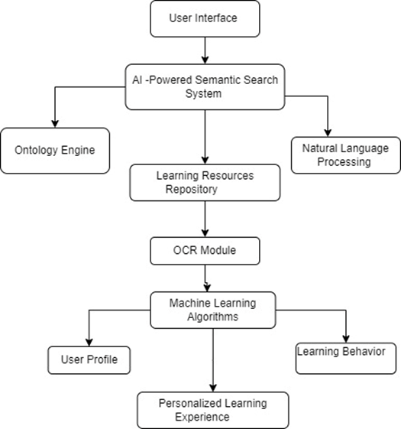

Figure 5.3.1: Proposed Methodology

The proposed system is an AI-powered semantic search and OCR-enabled e-learning platform designed to enhance the learning experience by providing advanced search capabilities, efficient content retrieval, and seamless integration of optical character recognition (OCR) technology. This section provides a detailed diagram for the system architecture, the AI and OCR technologies employed, and the key features of the platform.

The system architecture for the proposed platform is based on a client-server model. The client side consists of a user interface which allows learners to interact with the system, perform searches, and access learning materials. The server side comprises the backend components responsible for handling user requests, processing data, and delivering results. The architecture incorporates cloud infrastructure to ensure scalability, high availability, and efficient processing of AI algorithms.

* User Interface: The user interface (UI) serves as the visual gateway for students, instructors and admins to interact with the system and access its features and functionalities. It is designed to be intuitive, user-friendly, and efficient, allowing users to navigate through the platform and perform tasks effectively.
* Semantic Search System: The Semantic Search System is an important part of the proposed e-learning platform. It leverages machine learning algorithms, an ontology engine, natural language processing, and a Learning Resources Repository to deliver an enhanced search experience for users.
  + Machine Learning Algorithms: The system employs machine learning algorithms to improve the search functionality. These algorithms analyze user behavior, preferences, and historical data to provide personalized search results. By learning from user interactions, the algorithms continuously improve the relevance and accuracy of search results over time.
  + Learning Resources Repository: The Learning Resources Repository serves as a centralized storage system for all e-learning resources available on the platform. It encompasses a vast collection of educational materials, including text documents, multimedia files, presentations, and interactive content. The repository ensures that the learning resources are well-organized, easily accessible, and readily available for users to search, retrieve, and consume.
* OCR Module: The OCR (Optical Character Recognition) module is an important part of the proposed e-learning platform. It plays a crucial role in extracting text from scanned images of documents, thereby enabling searchability and accessibility of content that is not available in digital format. This module is particularly valuable for historical documents and other physical materials that have been digitized.
  + Image Processing: The OCR module utilizes image processing algorithms to enhance the quality of scanned images. This may involve tasks such as noise reduction, contrast adjustment, and image normalization. By optimizing the visual quality of the scanned documents, the OCR module ensures accurate text extraction.
  + Text Extraction: Using advanced OCR algorithms, the module analyzes the processed images and recognizes the textual content present within them. It employs ML and pattern recognition techniques to identify characters, words, and sentences in the image, converting them into machine-readable text.
  + Accuracy and Error Correction: To ensure high accuracy in text extraction, the OCR module incorporates error correction mechanisms. It compares the extracted text with known dictionaries, performs spell-checking, and applies contextual analysis to rectify any inaccuracies or errors in the recognized text.
  + Document Conversion: The OCR module can also convert the extracted text into plain text. This allows users to download or export the digitized content in a format that suits their needs.
* Personalized Learning Experience: This component is the result of ML techniques and provides a tailored learning experience for each user. The personalized learning experience includes customized recommendations for learning resources, activities, and assessments that are the same as the user's interests and learning style. This component helps students to stay engaged and motivated throughout the learning process, leading to better learning outcomes.

### 5.3.2 Module of project

* User Management: This module handles user registration, authentication, and profile management. It includes features such as user roles (students, instructors, administrators), user account settings, and password management.
* Course Management: This module allows instructors to create and manage courses. It includes features such as course creation, course editing, assignment management, grading, and scheduling.
* Content Management: This module enables instructors to upload and manage course materials such as lecture slides, videos, and documents. It may also include features for organizing content into modules or topics.
* OCR Integration: If OCR functionality is included, this module enables the conversion of scanned or image-based documents into searchable and editable text. It may involve integrating OCR libraries or technologies, processing uploaded documents, and making the extracted text available for search or display.
* Administrative Tools: This module provides administrators with tools and features for managing users, courses, and system settings. It includes features such as user and role management, course authorization, system configuration, and security settings.

### 

### 

### 

### 

### 

### 

### 

### 

### 

### 

### 

### 

### 

### 

### 5.3.3 Use case Diagram

The following use case gives a brief idea of how the primary actors (user, system) relate to each other and what actions they would perform in the initial working stage of the whole system. There initially an actor who is a visitor after registration he either becomes student or teacher.

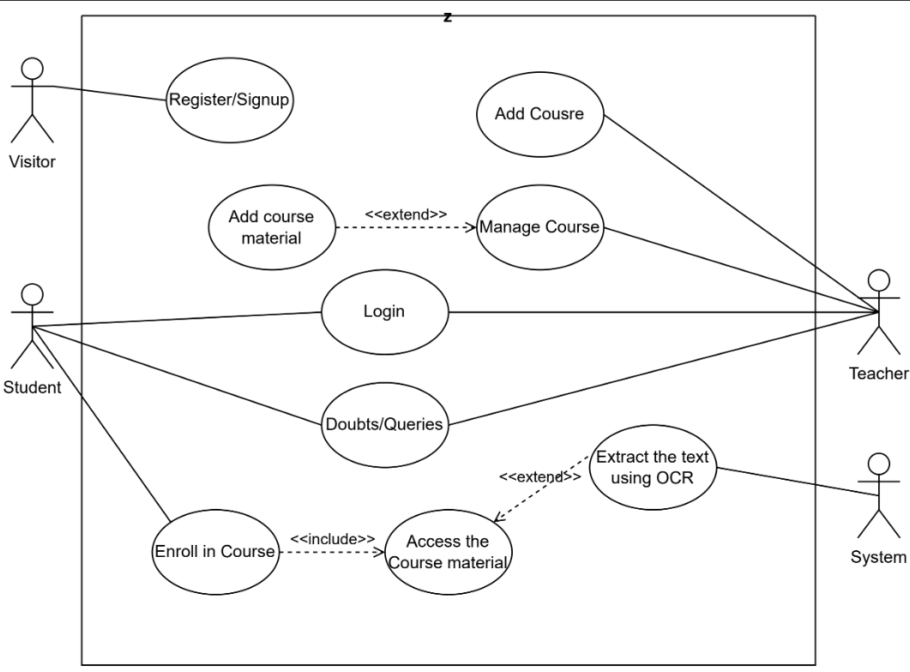

Figure 5.3.3: Use case diagram

### 5.3.4 Class Diagram

Class diagram is a visual representation that depicts the structure and relationships among classes in a system. It provides a high-level overview of the classes, their attributes (data), and methods (functions or operations), as well as the associations, inheritance, and other relationships between classes. The class diagram describes various classes in the system and how they interact with each other in the system.

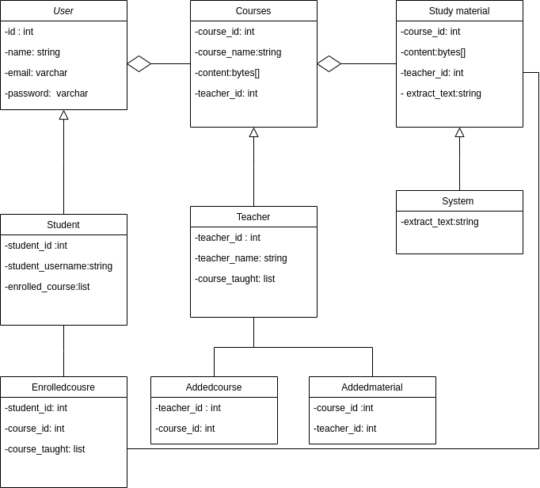Figure 5.3.4 : Class diagram

### 5.3.5 Activity Diagram

In this activity diagram a graphical representation of a system's workflow or process flow is given. It illustrates the sequence of activities, actions, and decisions involved in a particular process or use case. This diagram is used in software development to depict the dynamic behavior of a system. In an activity diagram, the workflow is represented using various shapes and symbols. The activity diagram shows the activities performed by the system, the teacher and the students.

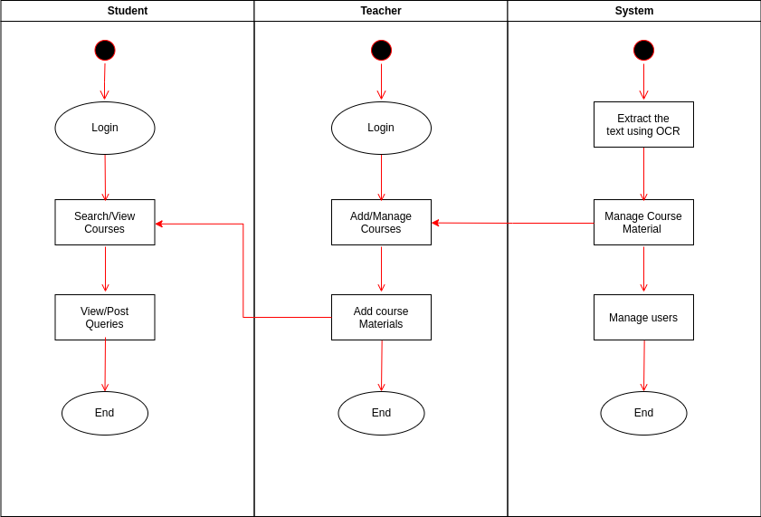

Figure 5.3.5 Activity diagram

# 

# 

# 

# Chapter 6 Project Plan

In January, after being allocated to Prof. Dipali Baviskar as our project guide, we had a meeting to discuss our Project Topic and Objectives to work upon. We selected a few topics and after proper analysis of features we came up with an E-Learning Management System using OCR and Semantic Search.

During the months of February and March we did Literature Survey and Market Research of Various currently Present E-Learning Platforms and their features, we did requirements gathering and Dataset Preparation.

From mid of March till April, we started Implementing our project using Angular and MySQL and also started working on the Research Paper. Once we were ready with our base project, during the month of April to June we added OCR and Semantic Search as our main features to the project making it more advantageous. By mid May we were ready with our fully functional E-Learning Management System.

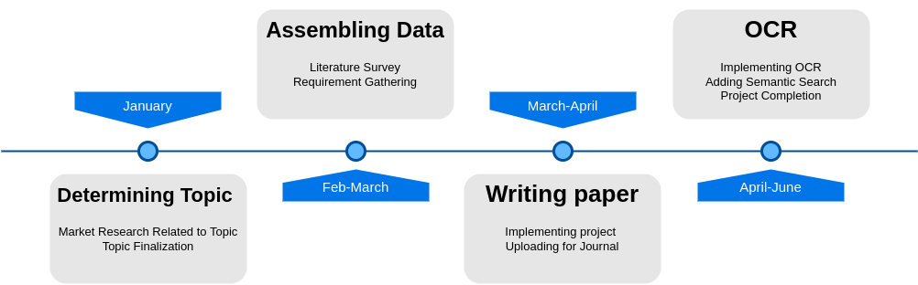Figure 6: Project Plan

# Chapter 7 Implementation

## 7.1 Frontend

We have used AngularJS For the Frontend. Angular is a widely-used open-source framework for building dynamic web applications. This is a client-side framework that helped us to build single-page applications using HTML, CSS, and JavaScript. It offers a range of features and functionalities, including a robust component-based architecture, declarative templates, and dependency injection. It was used in the development of Eduline's front-end, providing a solid and scalable foundation for building dynamic and responsive web applications.

Angular Material is a library we used to build UI components and styles of our web applications. It provides a range of pre-built components, including buttons, forms, dialogs, and data tables, that can be easily customized to match the design of any web application. Angular Material was used in the development of Eduline's UI, providing a consistent and intuitive user experience across the platform.

### 7.1.1 User Design and Interface:

Eduline, an online educational platform, boasts a user interface that prioritizes usability and accessibility. The platform offers a consistent and intuitive user experience, ensuring that students, instructors, and administrators can easily navigate the platform and access its features.

### 7.1.2 Home Page

The home page of an online platform designed for education would typically feature login and signup options for both teachers and students. The purpose of these options is to allow users to access the platform and utilize its various features based on their respective roles.

Login Option:

The login option allows users who already have an account to access the platform using their registered credentials. When users click on the login button, they are directed to a login page where they have to enter their email and password. The login process may also involve additional security measures such as two-factor authentication to ensure the safety of user accounts.

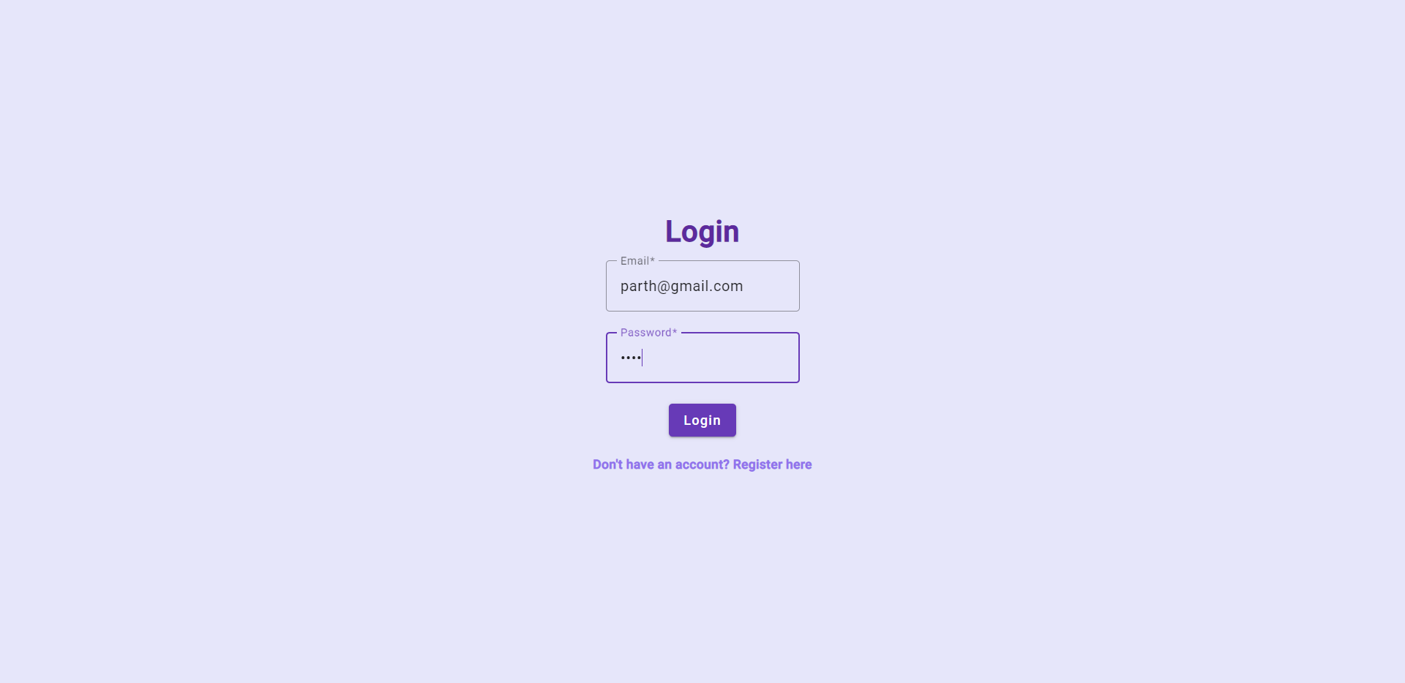

Figure 7.1.1: Login Page

Signup Option:

The signup option caters to new users who want to create an account on the platform. When users click on the signup button, they are directed to a registration page where they can provide the required information to create an account. The registration process may involve filling out a form that includes fields such as name, email address, username, password, and any other relevant details. The form may also include additional options to specify whether the user is a teacher or a student.

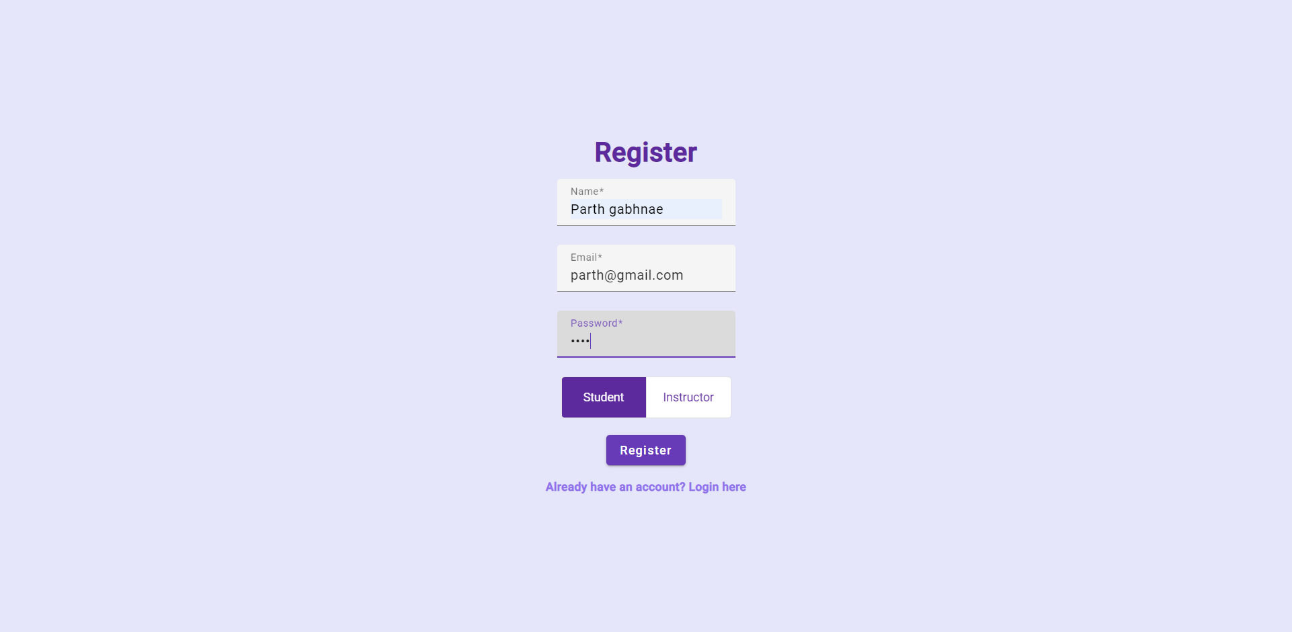

Figure 7.1.1: Signup Page

Teacher Account:

For teachers, the signup process may include additional fields to gather information about their professional background, qualifications, and subject areas of expertise. This information helps the platform match teachers with relevant students or subjects and enables students to find suitable instructors. Once registered as a teacher, users can access their account by logging in and gaining access to features such as creating and managing courses, uploading learning materials, setting assignments, and interacting with students.

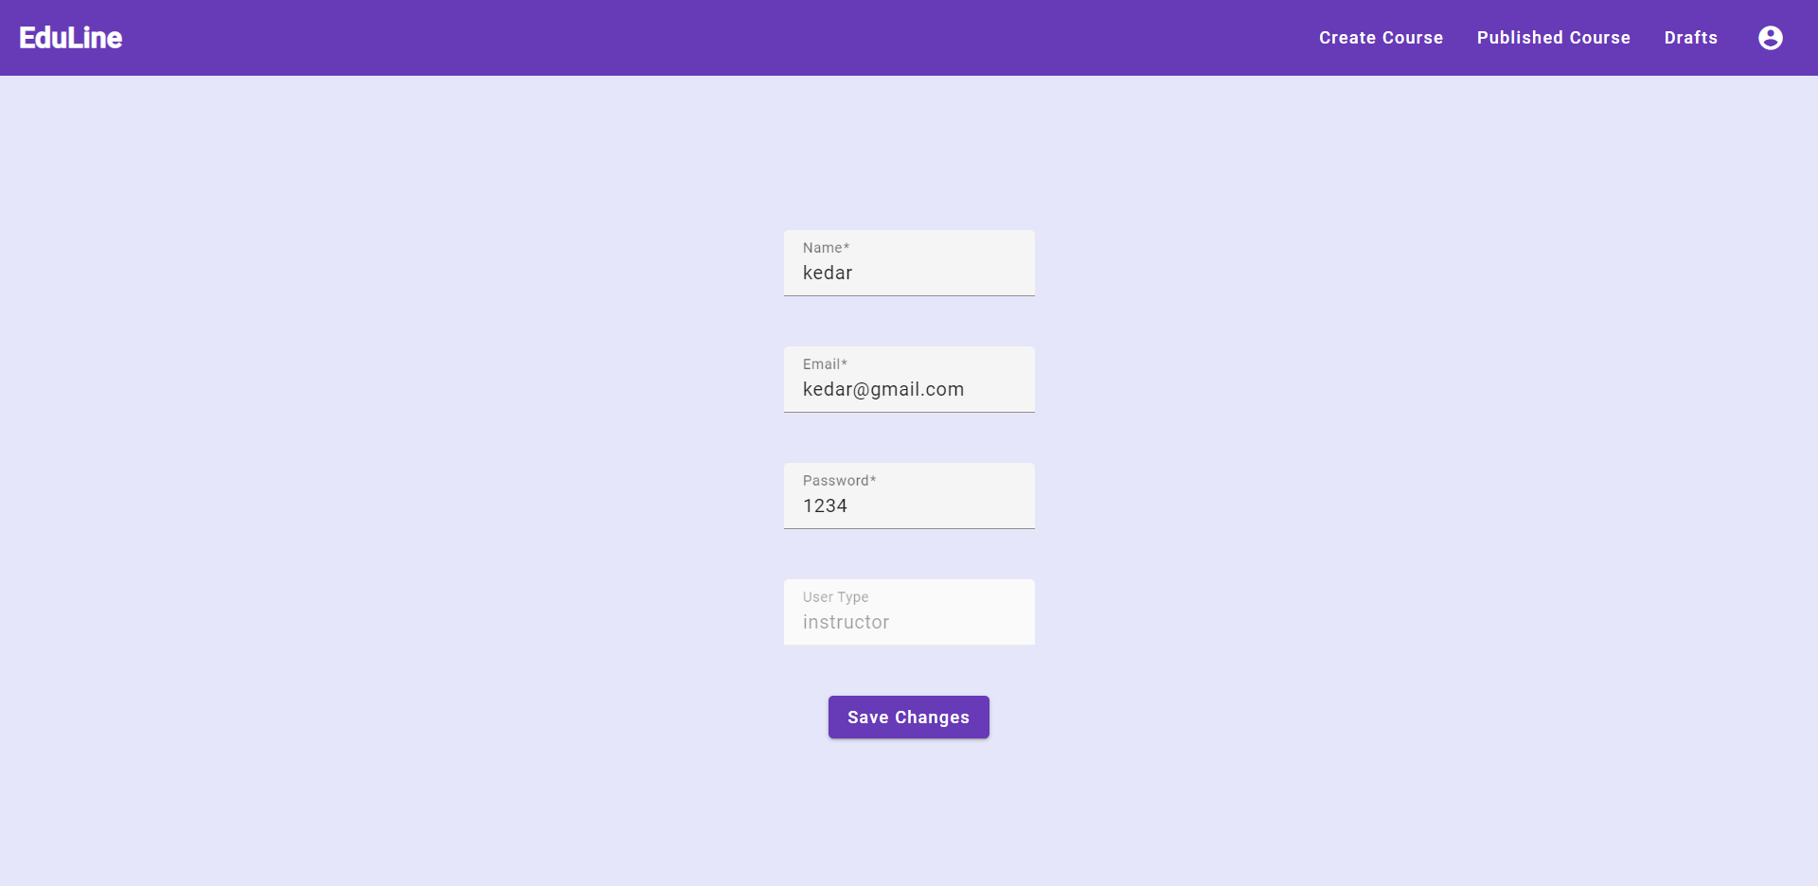

Figure 7.1.1: Instructor Account page

Student Account:

For students, the signup process may include fields to gather basic information such as name, email address, and grade level. This information helps the platform tailor the learning experience to each student's needs. Once registered as a student, users can access their account by logging in and gain access to features such as browsing and enrolling in courses, accessing learning materials, submitting assignments, participating in discussions, and tracking their progress.

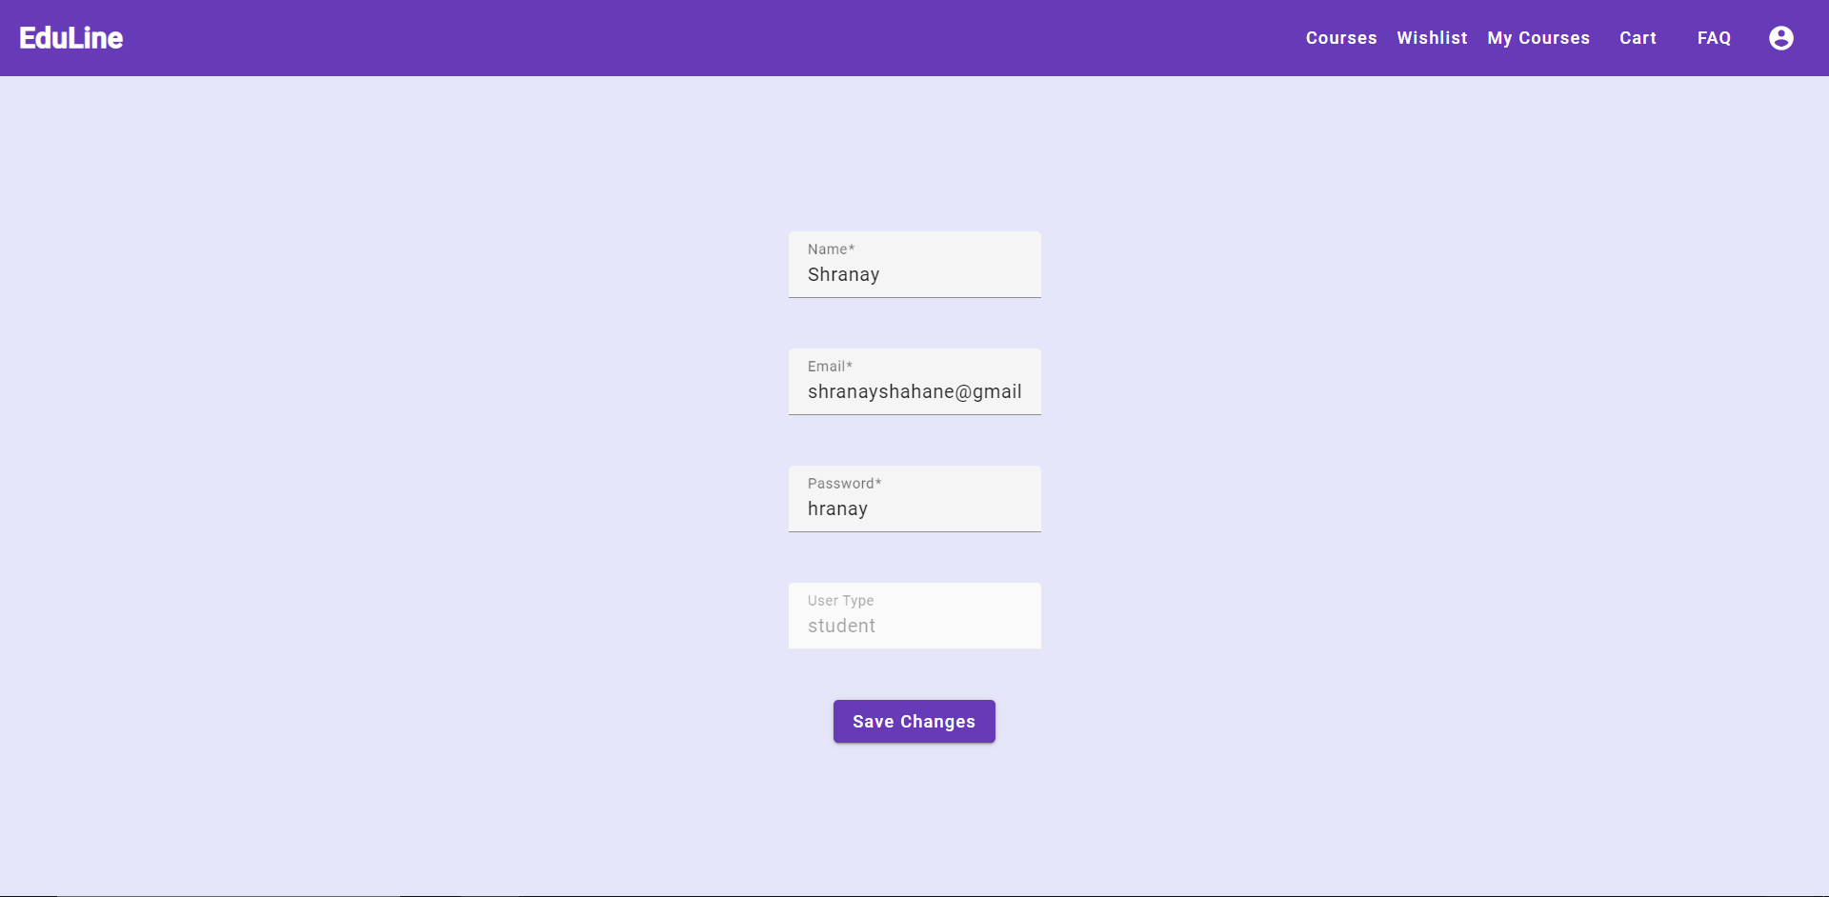

Figure 7.1.1: Student Account page

User Authentication:

To make sure that the security and privacy of user accounts does not suffer, the login and signup processes typically involve user authentication mechanisms. These mechanisms verify the identity of users, protect against unauthorized access, and safeguard personal information. Common authentication methods include username and password combinations, email verification, and two-factor authentication (2FA) that requires users to enter a unique code sent to their registered mobile device or email.

User-Friendly Interface:

The home page should have a user-friendly interface with clear and intuitive design elements. It should provide easy-to-understand instructions and prompts for users to log in or sign up. The login and signup options can be prominently displayed, either as buttons or links, to guide users to the appropriate pages. The interface may also include visual cues or icons representing teachers and students to assist users in selecting the relevant option.

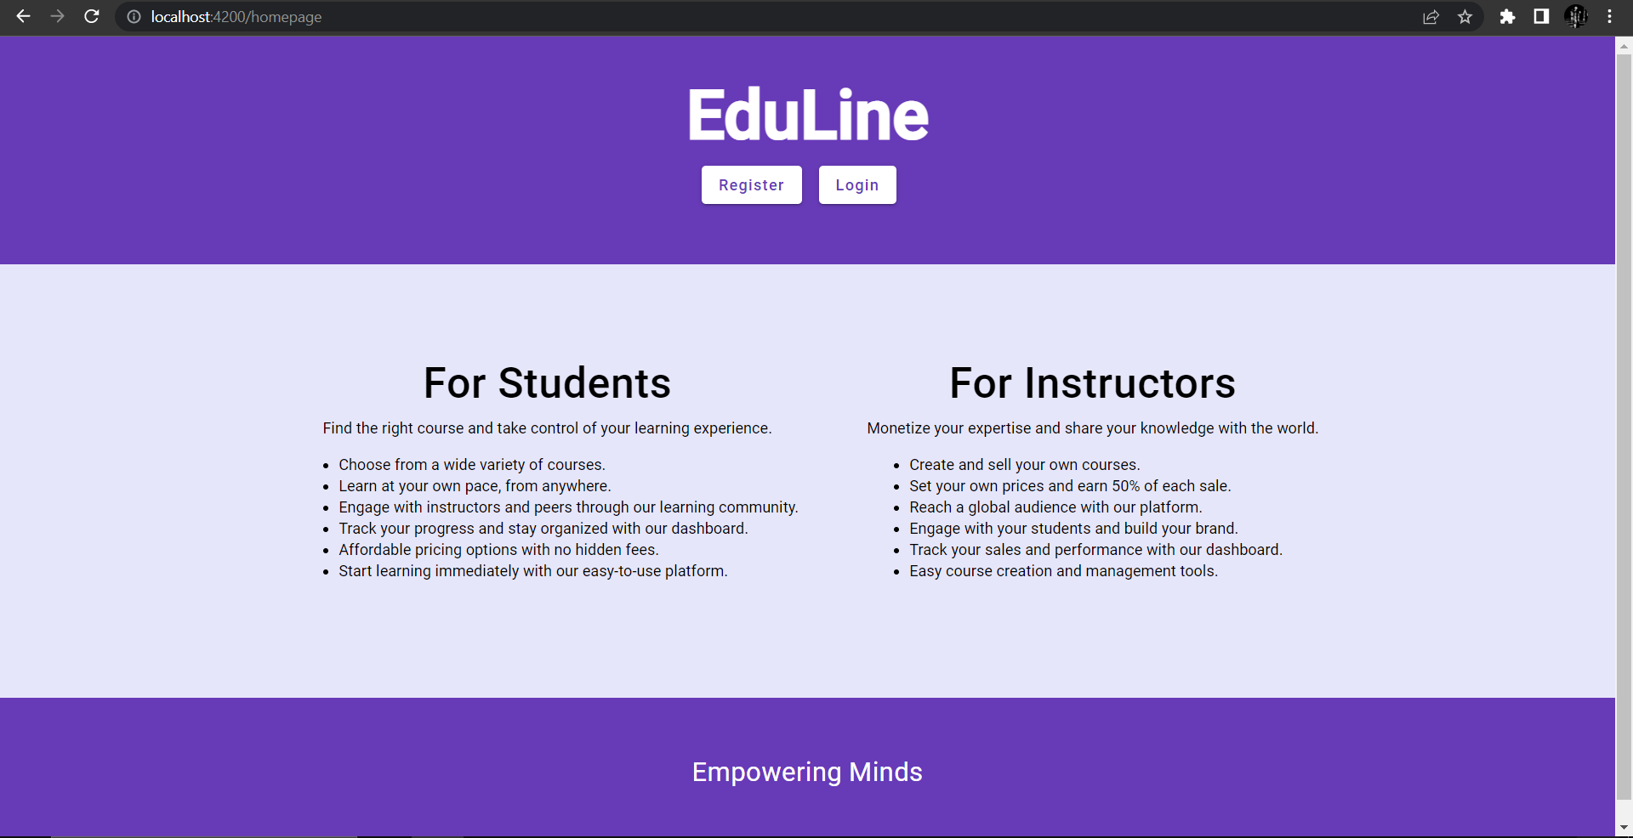

Figure 7.1.1: Landing Page

### 7.1.3 Navbar

At the top of the Eduline platform, there is a navigation bar (navbar) that facilitates easy navigation for each type of user. The navbar employs a modern and minimalist aesthetic, utilizing icons and text to clearly communicate the available options. To cater to the distinct needs of regular users, instructors, and administrators, the navbar is divided into dedicated sections. This segmentation allows for effortless access to relevant features and functionalities.

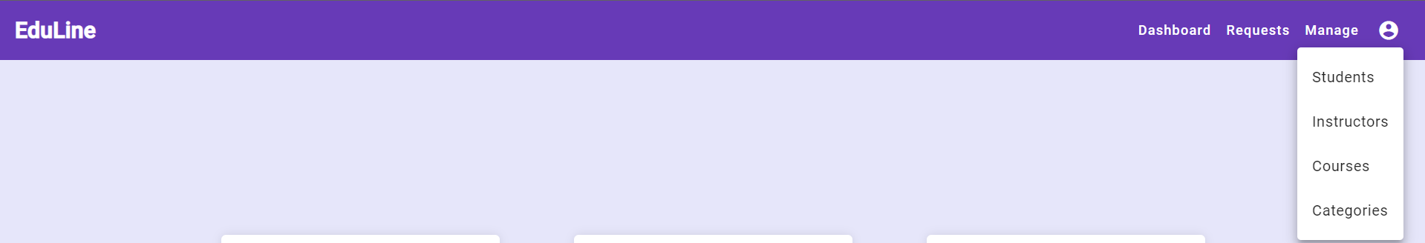Figure 7.1.2: Admin Navbar

Figure 7.1.3: Instructor Navbar

### 

### 7.1.4 User Dashboard

The user dashboard serves as a centralized hub for students, granting them convenient access to their courses and associated materials. Upon entering the dashboard, students are presented with a list of their enrolled courses. To provide an overview of progress, a progress bar accompanies each course, indicating the completion percentage. Additionally, users can conveniently access their bookmarks, course history, and profile settings directly from the dashboard, streamlining the user experience.

### 7.1.5 Course Page

Every course within Eduline possesses a dedicated page that provides a comprehensive overview of its contents, materials, and progress tracking. On the course page, a list of modules and lessons is presented, accompanied by a progress bar that showcases the student's completion status. Supplementary materials, including PDFs, ZIP files, and video lectures, are readily accessible from the course page, enabling learners to access relevant resources with ease.

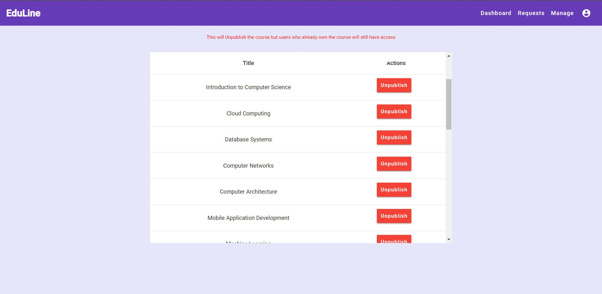Figure 7.1.4: Admin Courses Page

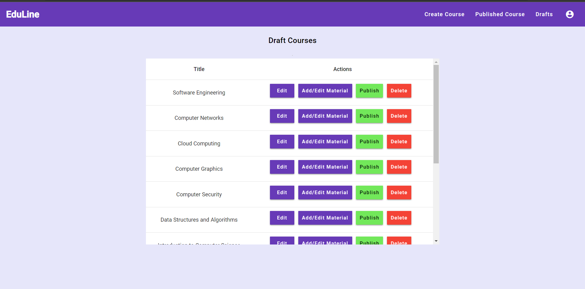Figure 7.1.5:Instructor Courses Page

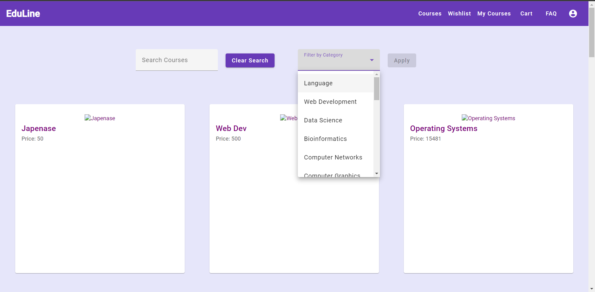Figure 7.1.6:Student Courses Page

### 7.1.6 Instructor Dashboard

The instructor dashboard functions as a centralized hub for instructors, empowering them to create and manage their courses effectively. In this dashboard, instructors encounter a list of their courses, each accompanied by a progress bar indicating the completion level. Furthermore, instructors can access their earnings, account settings, and course analytics from the dashboard, enabling efficient monitoring and management of their educational offerings.

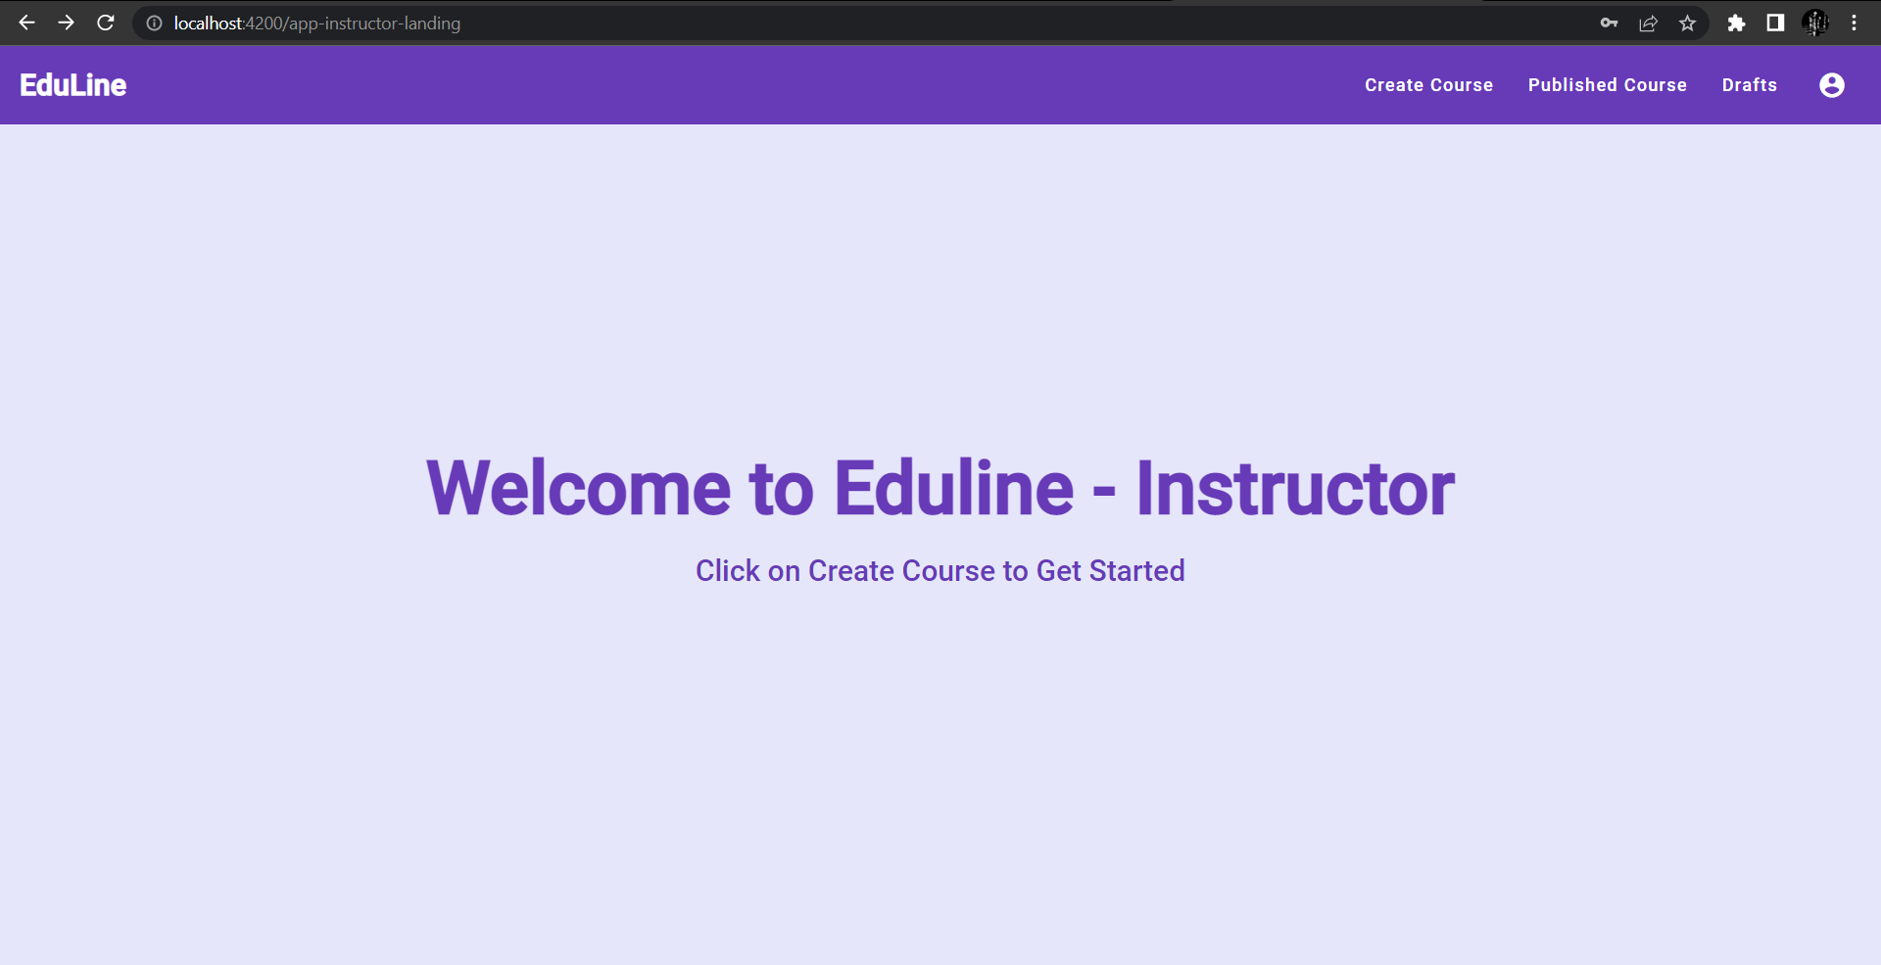Figure 7.1.7: Instructor Dashboard

### 7.1.7 Admin Dashboard

The admin dashboard serves as a comprehensive control center for administrators, allowing them to manage the Eduline platform and its user base. The dashboard provides administrators with access to essential information, such as a list of courses, instructors, and users. Admins are equipped with an array of options to manage and authorize these elements effectively. Additionally, administrators can review their earnings, adjust account settings, and leverage platform analytics to gain valuable insights, all within the admin dashboard.

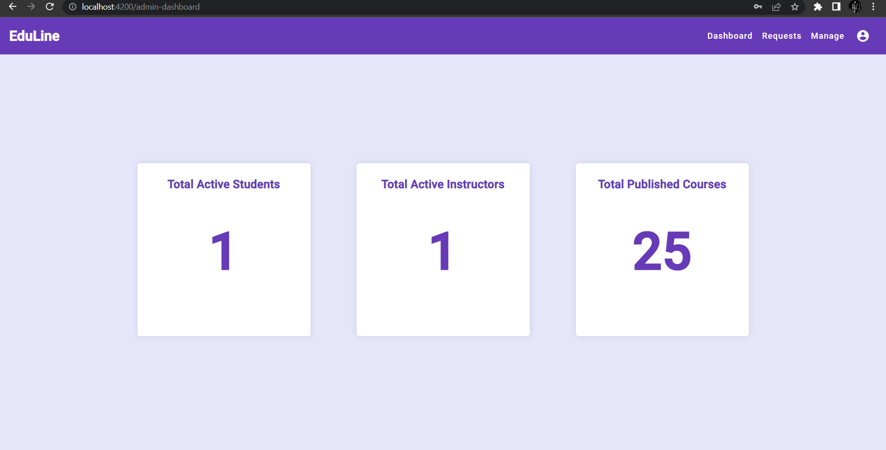Figure 7.1.8: Admin Dashboard

### 7.1.8 Creating Course Material

To create a new course on your website, you need to gather specific information and follow a set of steps. Here's a detailed breakdown of the process:

#### 7.1.8.1 Course Information:

To begin, you will require the following details about the course:

a. Title: The title represents the name or headline of the course, which should clearly convey the subject or topic.

b. Description: The description provides a comprehensive overview of the course content, objectives, and outcomes. It helps potential learners understand what they can expect from the course.

c. Keywords: Keywords are relevant terms or phrases associated with the course. They assist in search engine optimization (SEO) and help users find the course when searching for specific topics.

d. Price: Determine the price or pricing structure for the course. This can be a fixed price, a subscription-based model, or any other pricing strategy that aligns with your business model.

e. Category: Assign the course to a specific category or multiple categories to ensure proper organization and ease of navigation on your website.

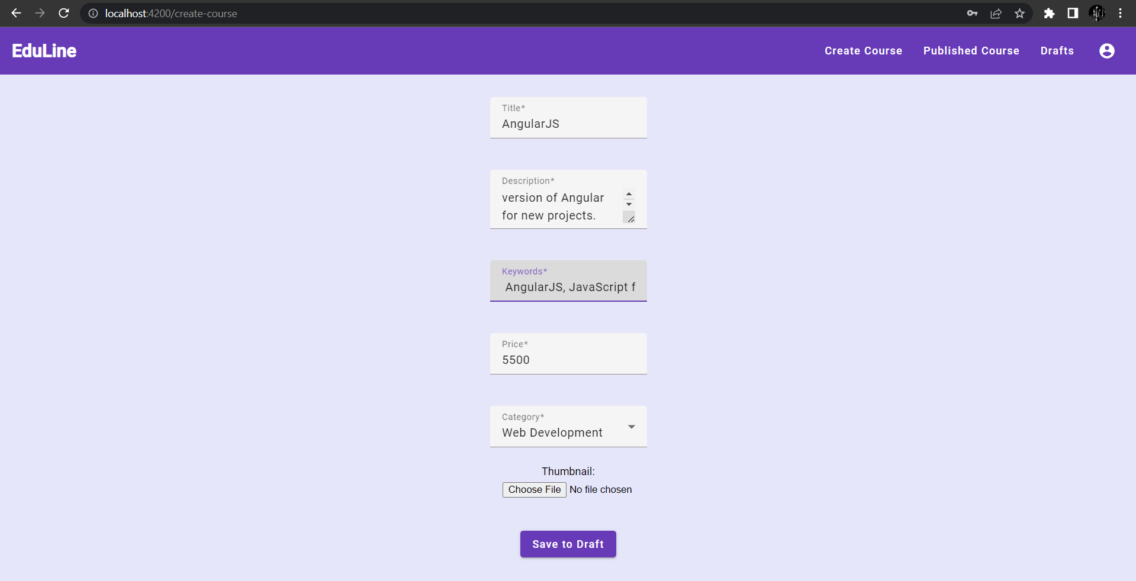

Figure 7.1.9: Creating Course material

Uploading Course Materials:

The course materials consist of various file types, including PDF, image, text, video, and general files. Each material type has different requirements and considerations. Here's how you can handle each type:

a. PDF: Users can upload PDF files containing text, images, and other content related to the course. No additional conversion is necessary for PDF files, as they are already in a readable format.

b. Image: Images, such as diagrams or illustrations, can be uploaded directly. However, if the image contains text that needs to be extracted for indexing or search purposes, Optical Character Recognition (OCR) can be applied to convert the image into a text format.

c. Text: Users can enter or copy and paste text directly into the course material. This can be helpful for providing textual instructions, code snippets, or other text-based content.

d. Video: Users can upload video files that contain instructional content, lectures, demonstrations, or other multimedia elements. Ensure that your website supports common video formats and provides appropriate video player capabilities.

e. File: General files, such as supplementary documents or code samples, can be uploaded as additional resources for the course.

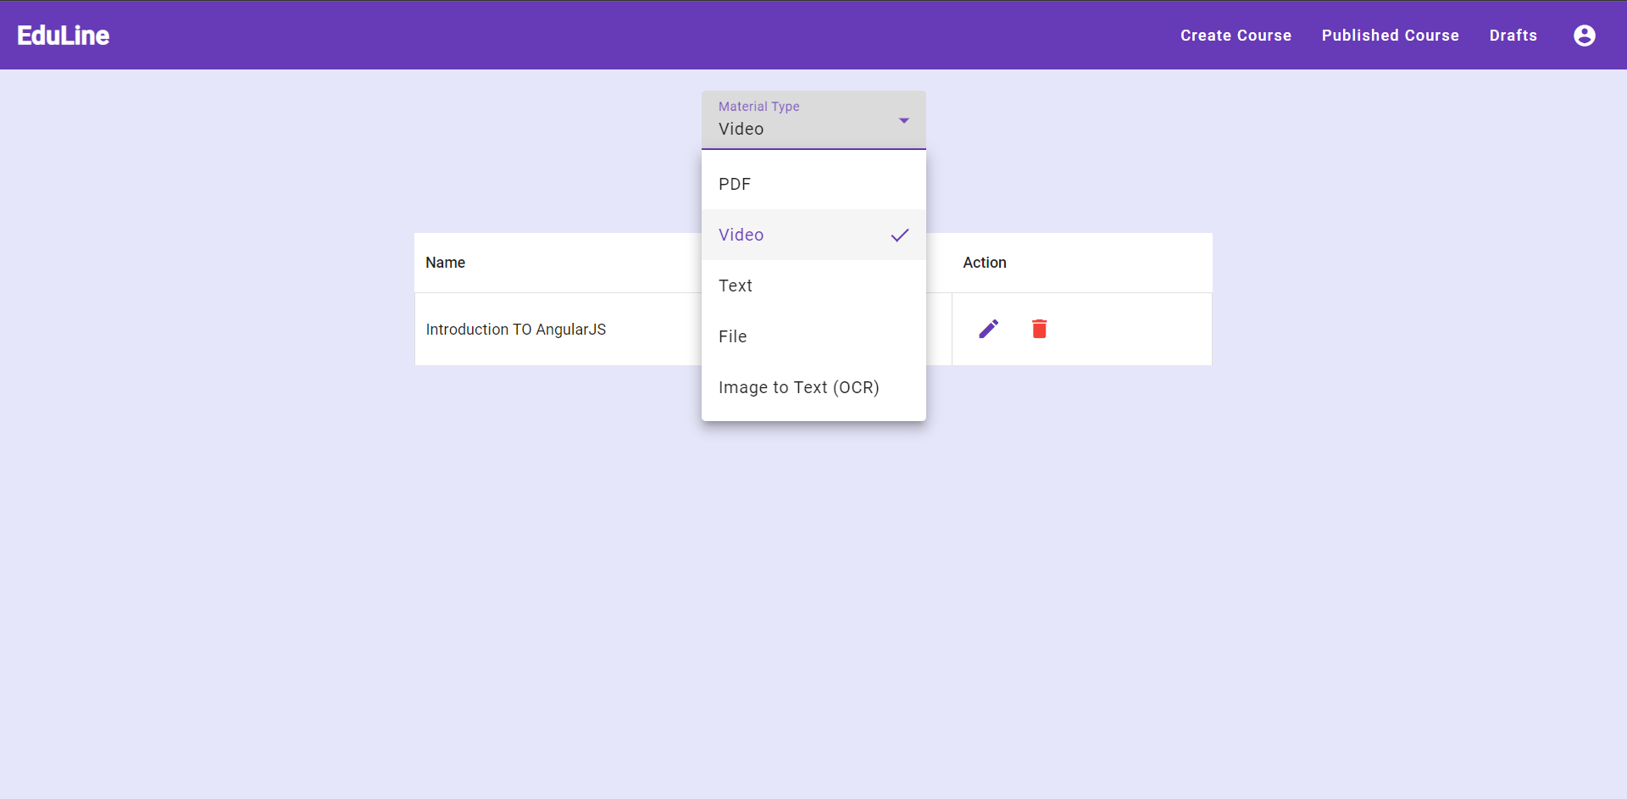

Figure 7.1.10: Creating Course material

OCR Conversion:

For images that contain text, implementing an OCR system allows you to extract the text from the image and convert it into a readable text format. OCR technology analyzes the image and recognizes characters, enabling searchability and indexing within the course material.

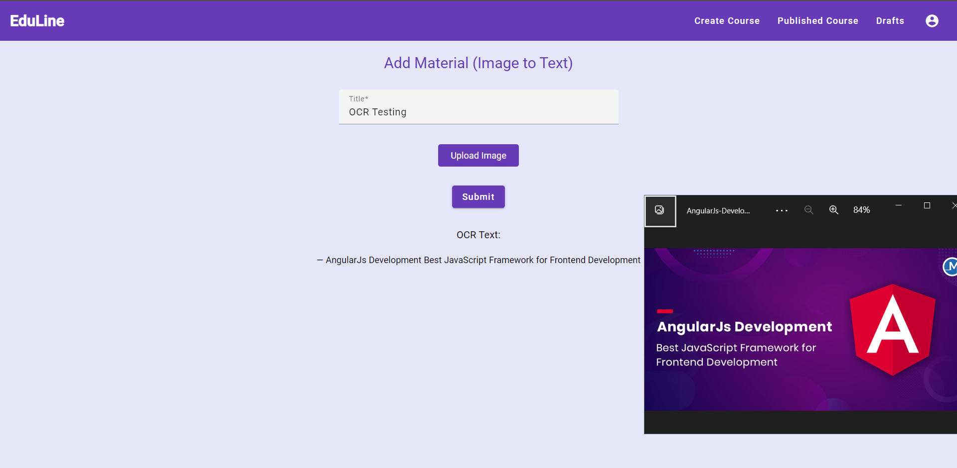

Figure 7.1.10: OCR Conversion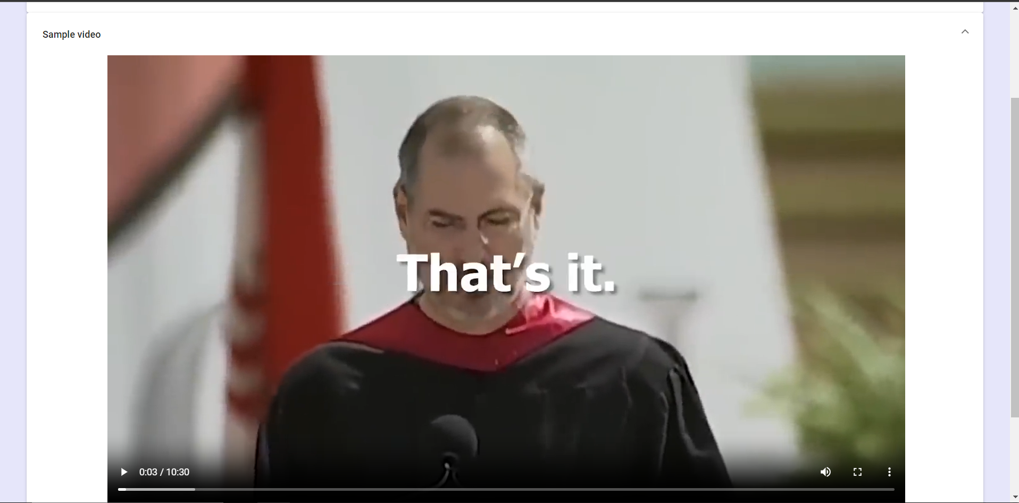

Figure 7.1.10: Uploaded video material

Admin Authorization:

After uploading all the course materials and providing the necessary information, the course requires authorization from an admin. This step ensures quality control and prevents unauthorized or inappropriate content from being published on the website. Admins can review the course details, materials, and overall suitability before granting permission for the course to be published and made available to learners.

By following these steps, you can create a new course on your website, including the necessary information, uploading various materials, converting images to text using OCR, and obtaining admin authorization. This process ensures that the courses offered on your website are well-structured, informative, and aligned with your quality standards.

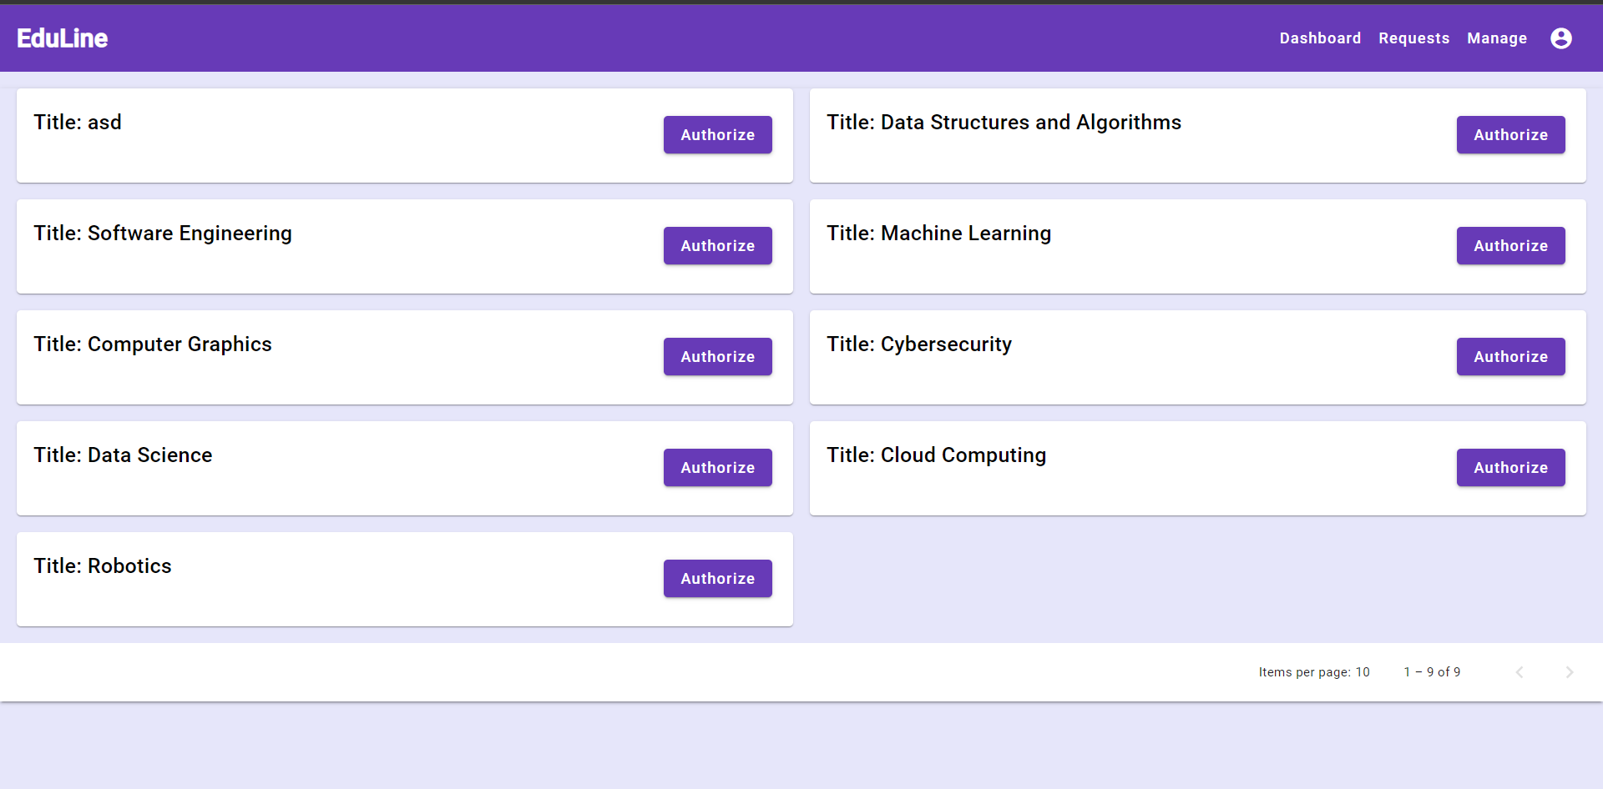

Figure 7.1.11: Admin Authorization for Courses

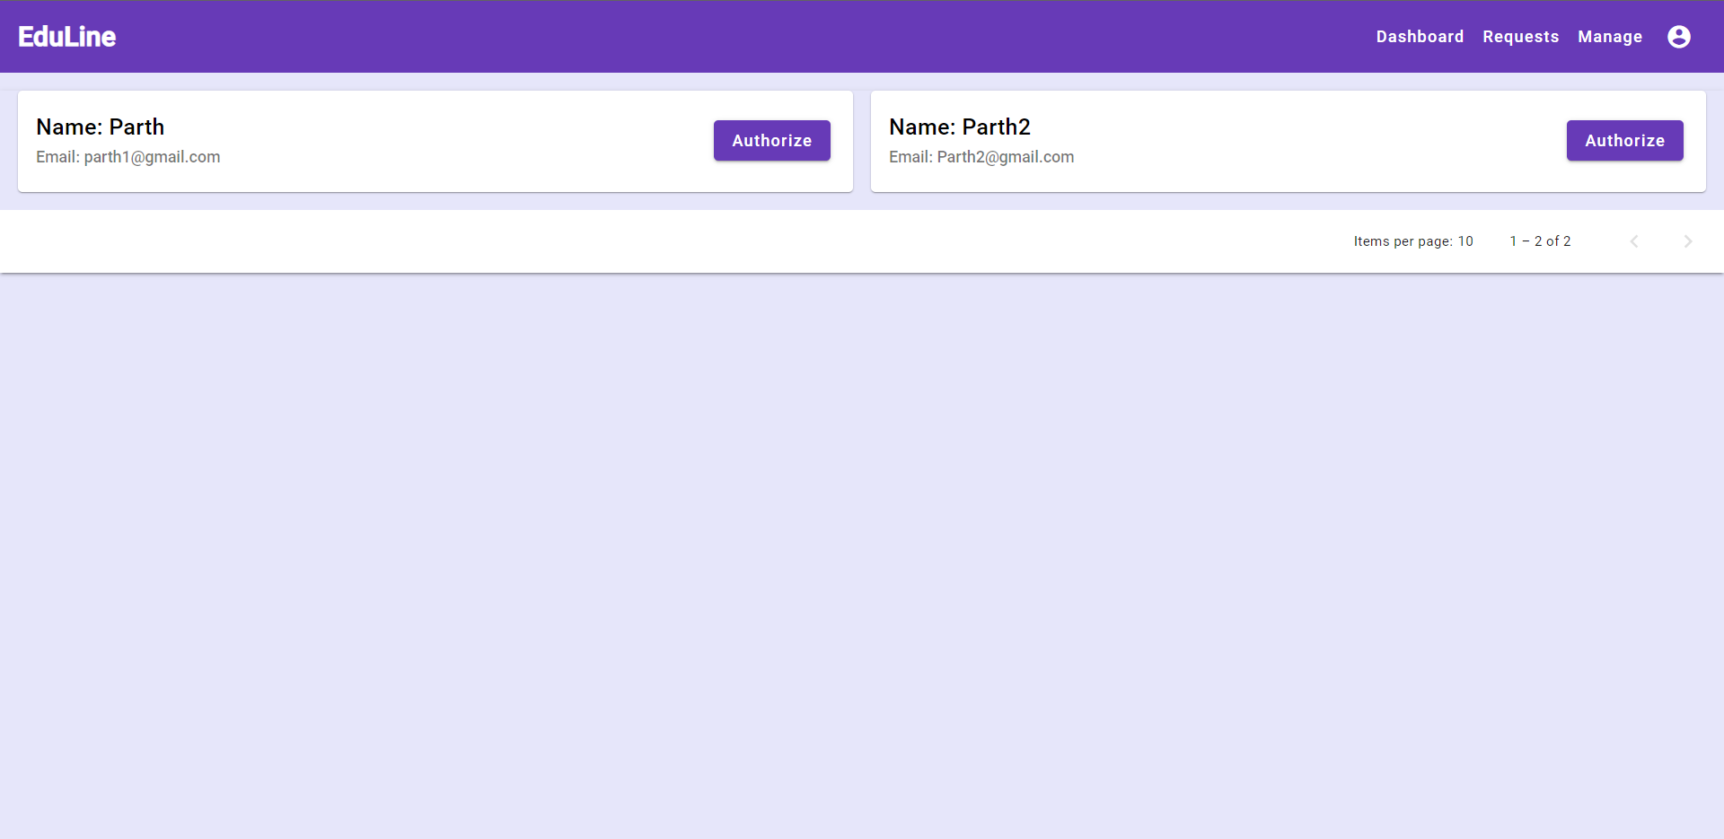

Figure 7.1.11: Admin Authorization for Instructor

### 7.1.8 Responsive Design

Eduline's user interface incorporates a responsive design approach, ensuring optimal accessibility and usability across all devices. The platform's layout and functionalities are optimized for mobile devices, delivering a seamless and intuitive user experience on smartphones and tablets. This responsive design enables learners, instructors, and administrators to engage with Eduline's educational resources effortlessly, regardless of the device they use.

## 7.2 Backend

We have used MySQL for Backend as an open-source relational database management system (RDBMS) that provides a powerful and scalable platform for managing and storing data.MySQL is widely used in web development and is a popular choice for powering dynamic websites and applications. It supports various programming languages, including PHP, Python, Java, and many others, making it compatible with a wide range of software applications.

MySQL has established itself as one of the most popular and widely used database management systems, especially in the web development community, due to its scalability and performance, security, replication and High Availability, reliability, and ease of use.

### 7.2.1 LMS Database and Tables

We created a database named ‘lms’ and used it to create the following tables along with its properties respectively:

#### 7.2.1.1 Admin Table

The "admin" table represents administrators or system users with administrative privileges. It includes columns such as "id" (unique identifier), "name" (name of the admin), "email" (email address of the admin), and "password" (hashed password for authentication).

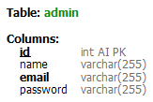 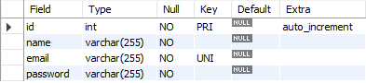

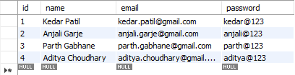

Figure 7.2.1.1: Database admin table

#### 7.2.1.2 Instructors Table

The "instructors" table contains details about course instructors. It includes fields such as "id" (unique identifier), "name" (name of the instructor), "email" (email address of the instructor), "password" (hashed password for authentication), "is_blocked" (a boolean indicating if the instructor is blocked), and "is_authorized" (a boolean indicating if the instructor is authorized).

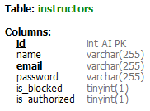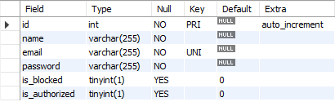

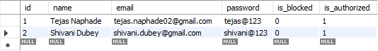

Figure 7.2.1.2: Database instructors table

#### 7.2.1.3 Students Table

The "students" table stores information about individual students. It includes columns such as "id" (unique identifier), "name" (name of the student), "email" (email address of the student), "password" (hashed password for authentication), and "is_blocked" (a boolean indicating whether the student is blocked or not).

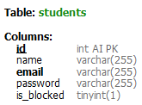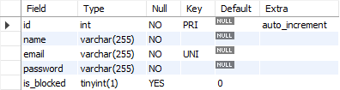

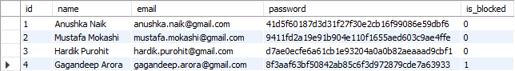

Figure 7.2.1.3: Database students table

#### 7.2.1.4 Course Categories Table

The "course_categories" table holds information about different categories or subjects for courses. It includes columns like "id" (unique identifier) and "name" (the name of the category).

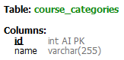

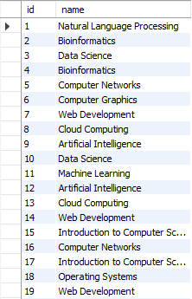



Figure 7.2.1.4: Database courses category table

#### 7.2.1.5 Courses Table

The "courses" table represents individual courses. It includes columns such as "id" (unique identifier), "title" (title of the course), "description" (a text field describing the course), "instructor_id" (the ID of the instructor associated with the course), "keywords" (keywords/tags associated with the course), "price" (the course price), "is_authorized" (a boolean indicating if the course is authorized), "is_published" (a boolean indicating if the course is published), "is_deleted" (a boolean indicating if the course is deleted), "category_id" (the ID of the course category), "thumbnail_url" (the URL of the course thumbnail), and "published_time" (the timestamp of when the course was published).

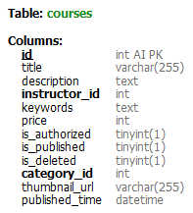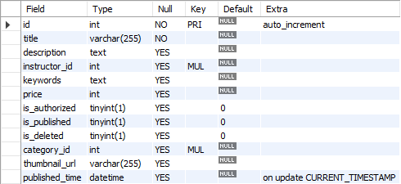

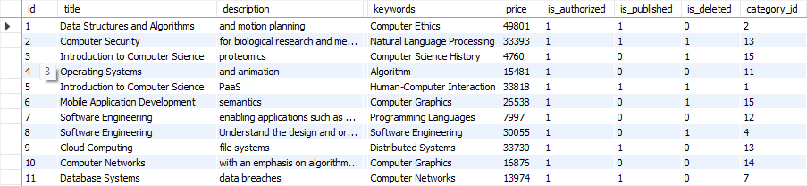

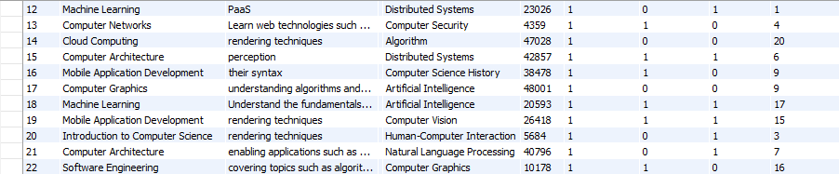

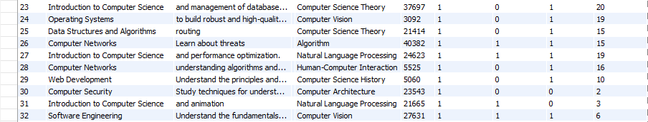

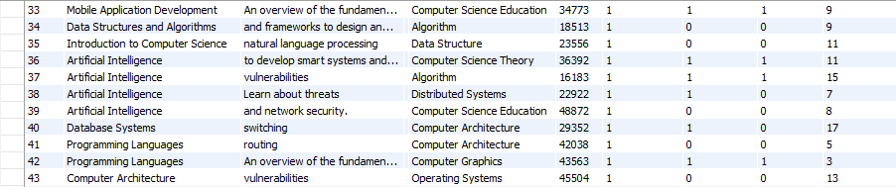

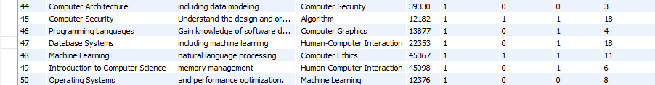

Figure 7.2.1.5: Database courses table

#### 7.2.1.6 Course Materials Table

The "course_materials" table stores information about materials associated with a course. It includes columns like "id" (unique identifier), "title" (title of the material), "description" (a text field describing the material), "course_id" (the ID of the associated course), "material_type" (the type of material, such as video, document, etc.), "file_url" (the URL of the material file), and "sequence_number" (a number indicating the order of materials within a course).

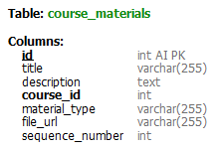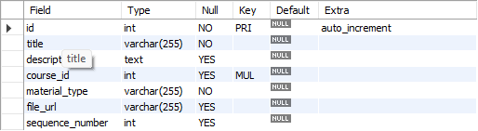

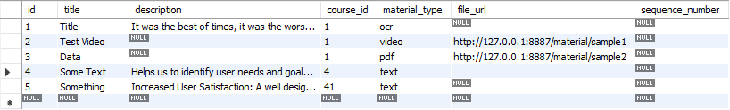

Figure 7.2.1.6: Database course material table

#### 7.2.1.7 Enrollments Table

The "enrollments" table keeps track of student enrollments in courses. It includes columns like "id" (unique identifier), "student_id" (the ID of the enrolled student), and "course_id" (the ID of the enrolled course).

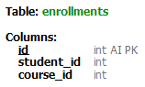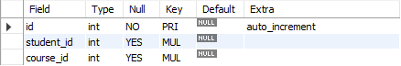

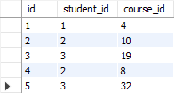

Figure 7.2.1.7: Database enrollments table

#### 7.2.1.8 Wishlist Table

The "wishlist" table stores student wishlists, which include courses the student has saved for future consideration. It includes columns like "id" (unique identifier), "student_id" (the ID of the student), and "course_id" (the ID of the course added to the wishlist).

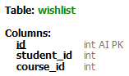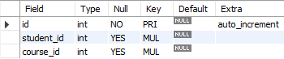

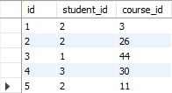

Figure 7.2.1.8: Database enrollments table

#### 7.2.1.9 Cart Table

The "cart" table maintains information about student carts or their selected courses for potential purchase. It includes columns like "id" (unique identifier), "student_id" (the ID of the student), and "course_id" (the ID of the course added to the cart).

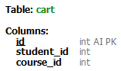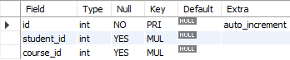

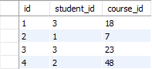

Figure 7.2.1.9: Database cart table

## 7.3 Data Set Description

The TextOCR dataset is a collection of data specifically designed for Optical Character Recognition (OCR) tasks. OCR is the process of converting printed or handwritten text into machine-readable text. The dataset aims to provide a diverse range of text samples to train and evaluate OCR models. It's a comprehensive dataset consisting of 25100 images, each containing valuable information regarding images that contain text. Alongside the images, the dataset also includes corresponding annot.csv, annot.parquet, img.csv and img.parquet files. This dataset was obtained from Kaggle, a popular online community and platform for data scientists and machine learning enthusiasts. Kaggle is widely recognized as a reputable and standard source for Optical Character Recognition (OCR) data, making it an ideal choice for acquiring reliable and diverse datasets.

The dataset's primary component is the collection of images, which serve as the basis for text extraction and analysis. These images encompass various types of documents, such as printed documents, handwritten notes, product labels, and more. The diverse nature of the images enables researchers and developers to explore different OCR algorithms and techniques and evaluate their performance on different types of text-containing images.

Accompanying images in the dataset are the annot.csv and img.csv files . The annot.csv files contain the Image Text annotations from the images, providing a ground truth reference for evaluating OCR accuracy. These files can be used for training machine learning models or benchmarking existing OCR systems.

The img.csv file, often used in conjunction with the annot.csv file, contains information about images such as its ID, height and width, as well as the bounding boxes that enclose each individual character or word in the images. These bounding boxes are essential for tasks such as text localization and text recognition. Researchers and developers can leverage the box files to enhance their OCR algorithms' precision by accurately identifying and segmenting text regions within the images.

Furthermore, the dataset encompasses annot.parquet and img.parquet files, leveraging the Parquet file format. Parquet is an open-source, column-oriented data file format explicitly designed for efficient storage and retrieval of data. It excels in handling large volumes of complex data. Parquet is renowned for its high-performance data compression capabilities and its ability to accommodate diverse encoding types.

With its substantial size and comprehensive collection of image-text pairs, TextOCR from Kaggle is a valuable resource for OCR research, algorithm development, and machine learning model training. Its wide range of image types and accompanying files enables researchers and developers to explore various approaches and algorithms for accurate text extraction from images.

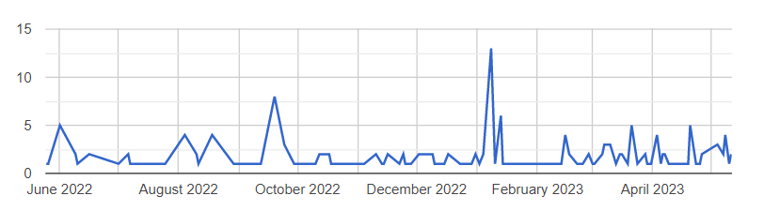Figure 7.3: Data entries since June2022 to April2023

## 7.4 Optical Character Recognition

### 7.4.1 Tesseract

Tesseract, developed by Google, is a highly regarded open-source Optical Character Recognition (OCR) engine. Renowned for its reliability and popularity, Tesseract excels at recognizing and extracting text from images. Its versatility makes it a valuable tool for tasks like document digitization, text analysis, and data extraction.

Originally developed at Hewlett-Packard Laboratories, Tesseract was later acquired by Google and released as an open-source project in 2005. Since then, it has undergone significant improvements and advancements, becoming a widely adopted OCR engine within the machine learning and data science communities.

Tesseract supports over 100 languages, making it a versatile tool for multilingual text extraction. It is trained on large datasets to accurately recognize a wide range of fonts, styles, and text sizes. Tesseract utilizes advanced image processing techniques, such as character segmentation and feature extraction, to identify and interpret individual characters within an image.

The OCR process with Tesseract typically involves several steps. First, the image containing the text is preprocessed to improve the quality and clarity of the uploaded file. This may involve operations such as noise reduction, contrast adjustment, and image normalization. Once the image is prepared, Tesseract applies its OCR algorithms to analyze the image and extract the text.

Tesseract generates machine-readable outputs, such as plain text or HTML, containing the recognized text. It also offers supplementary information, such as confidence scores for individual characters or words. These confidence scores aid in evaluating the accuracy and reliability of the OCR results.

**Built**

Image preprocessing: The first step is to preprocess the image to enhance its quality and make it easier to recognize the characters. This may involve techniques such as deskewing, binarization, noise removal, and contrast enhancement.

Character segmentation: Characters are identified and separated within the preprocessed image.

Feature extraction: Relevant features, such as shape, size, and orientation, are extracted from each segmented character and used as inputs to a machine learning model.

Machine learning: Tesseract employs a deep learning model to recognize characters, generating a probability distribution for each possible character.

Language modeling: Tesseract incorporates a language model to enhance accuracy by considering the probability of different word sequences and selecting the most likely word based on OCR output.

Post-processing: The OCR output undergoes post-processing, including error correction and accuracy improvement through techniques like spell checking, grammar checking, and context-based correction.

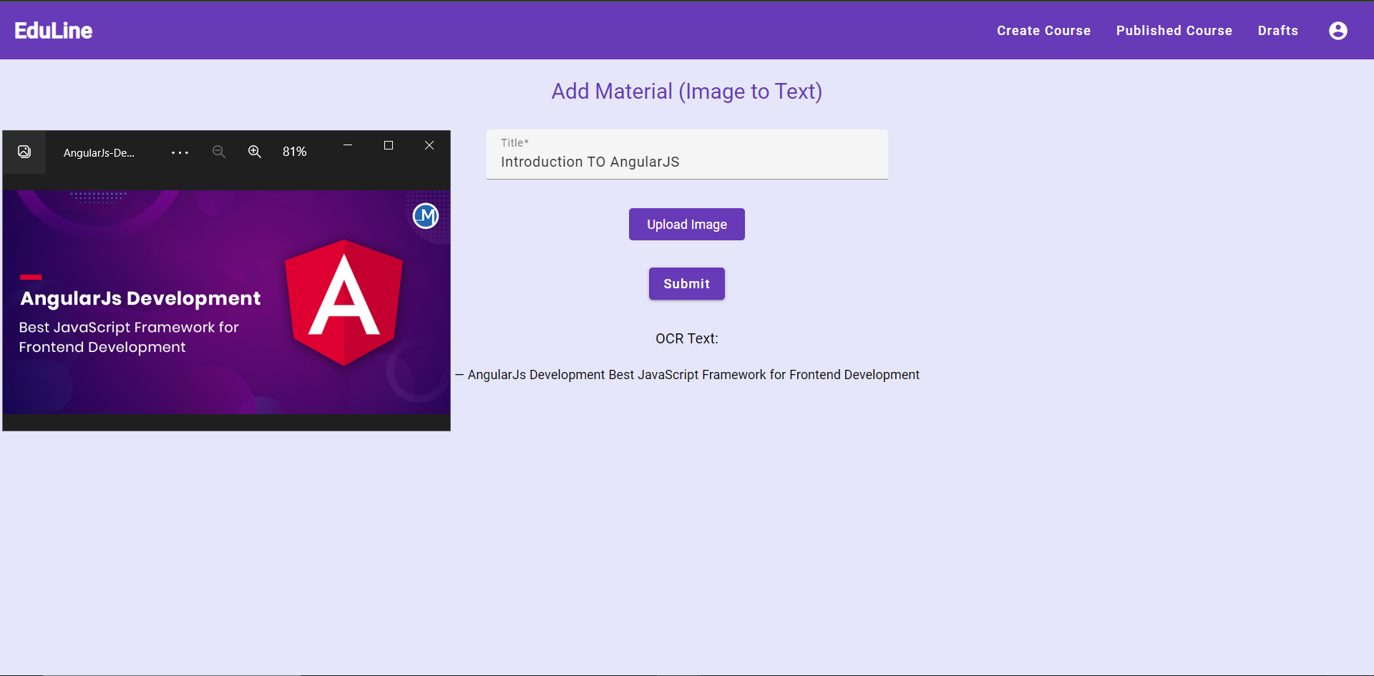

Figure 7.4.1: OCR view

## 7.5 Semantic Search

Semantic search is a search technique that aims to enhance accuracy and relevance of search results by understanding the intent and meaning behind the search query, rather than relying solely on keyword matching. It goes beyond traditional keyword-based search, which matches search queries with indexed keywords, and incorporates the understanding of context, synonyms, and relationships between words.

### 7.5.1 Introduction

Semantic search is a powerful technique that goes beyond traditional keyword matching to understand the intent and meaning behind user queries. TypeScript, with its static typing and extensive library ecosystem, offers a suitable platform for implementing semantic search systems. The following section provides an overview of methodology and objectives of Semantic Search.

### 7.5.2 Methodology

#### 7.5.2.1 Data Preprocessing:

Data preprocessing involves cleaning and normalizing text data to remove noise and facilitate subsequent analysis. TypeScript's string manipulation functions and regular expressions can be utilized to perform tasks like lowercase conversion, punctuation removal, and stopword elimination.

#### 7.5.2.2 Entity Recognition and Disambiguation:

Use NLP libraries compatible with TypeScript to perform entity recognition and disambiguation. These libraries provide functions or APIs to extract named entities from text. Fine-tuning the models or providing additional training data can improve entity recognition accuracy.

#### 7.5.2.3 Concept Extraction:

Extracting important concepts or topics from text is essential for semantic understanding. Various techniques like keyword extraction, topic modeling, or domain-specific methods can be employed. NLP libraries may offer built-in functions for concept extraction, or custom algorithms can be implemented.

#### 7.5.2.4 Semantic Representation:

Transform preprocessed text and extracted entities into a semantic representation that captures the meaning and relationships between words and concepts. TypeScript-compatible libraries like Word2Vec.js can be employed to convert words into dense vector representations using pre-trained word embeddings.

#### 7.5.2.5 Knowledge Graph Construction:

If the semantic search system involves a knowledge graph, TypeScript-compatible graph database libraries like Neo4j or Graphile can be used to represent structured relationships between entities and concepts. These libraries provide TypeScript bindings for interacting with the graph database.

#### 7.5.2.6 Query Understanding:

Develop algorithms or functions to understand user queries by extracting entities, concepts, and their relationships. NLP libraries can assist in query understanding, employing techniques such as syntactic and semantic parsing.

#### 7.5.2.7 Semantic Search Algorithms:

Implement search algorithms that leverage the semantic representation of documents and queries to retrieve relevant results. Techniques like semantic similarity calculation or machine learning approaches can be employed. TypeScript allows the implementation of these algorithms based on specific requirements.

#### 7.5.2.8 User Interface:

Design and develop a user-friendly interface using TypeScript-based web development frameworks like React or Angular. Implement input fields for user queries and display search results in an intuitive and meaningful manner. Communicate with the backend semantic search logic through APIs.

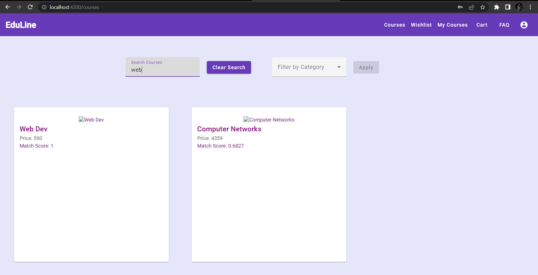Figure 7.4.2.8 Semantic similarity in the search query

# 

# 

# 

# 

# 

# Chapter 8 Performance and Result Analysis

#### 8.1 Description

As part of our project, we conducted a thorough comparison of three OCR algorithms: KerasOCR, EasyOCR, and TesseractOCR. Our goal was to determine which algorithm would best suit our needs in terms of performance speed and accuracy. To achieve this, we utilized a dataset consisting of 25 images containing various types of text.

#### 

#### 8.2 Data set description

The Image Text Recognition Dataset is a collection of 25 diverse images gathered in order to extract and recognize text. These images encompass a range of subjects and content types to provide a comprehensive dataset for training and evaluating OCR (Optical Character Recognition) algorithms.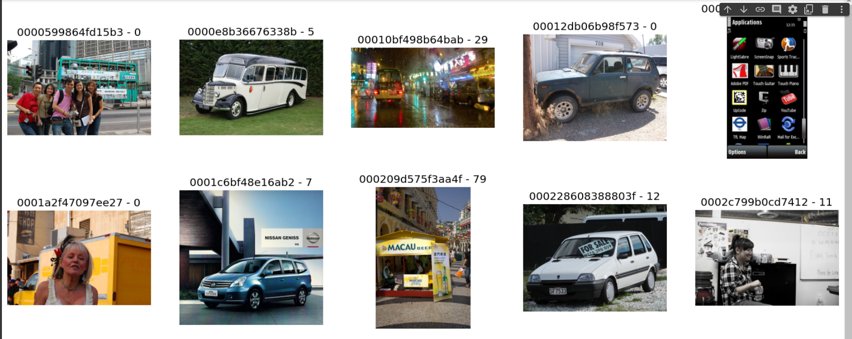

Figure 8.1 Dataset Images

#### 8.3 Comparing results

Upon analyzing the results, it was evident that the TesseractOCR algorithm outperformed the other two algorithms in terms of both speed and accuracy. It exhibited exceptional proficiency in swiftly and precisely recognizing text from the images in our dataset. Notably, its processing speed and the accuracy of the extracted text were particularly impressive.

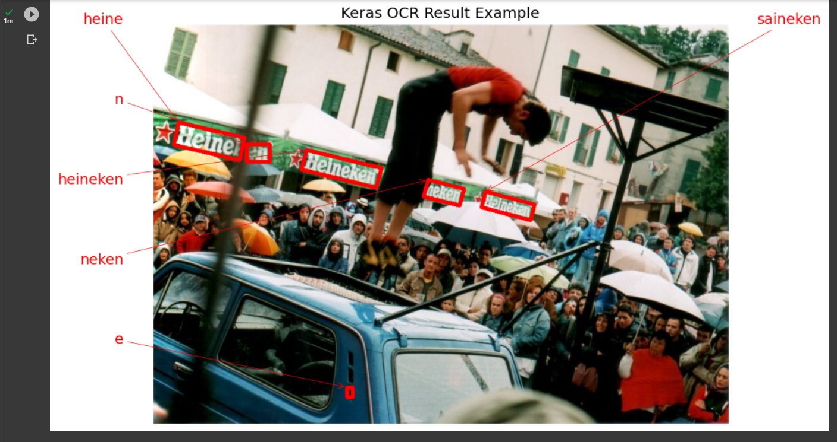

Figure 8.2 Keras OCR Result

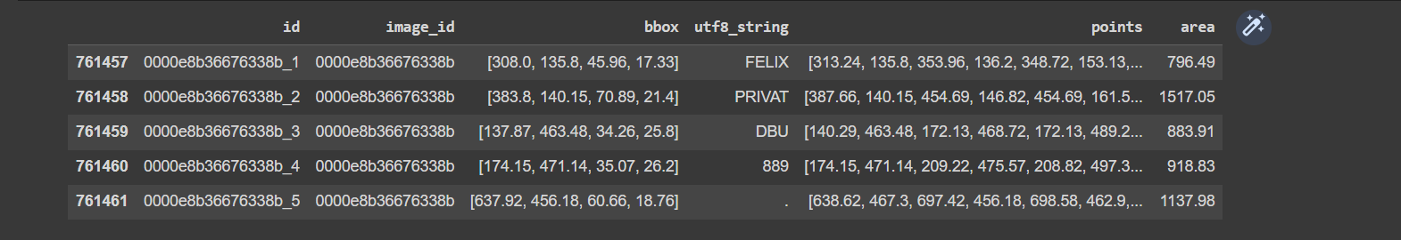

Figure 8.3 Easy OCR Result

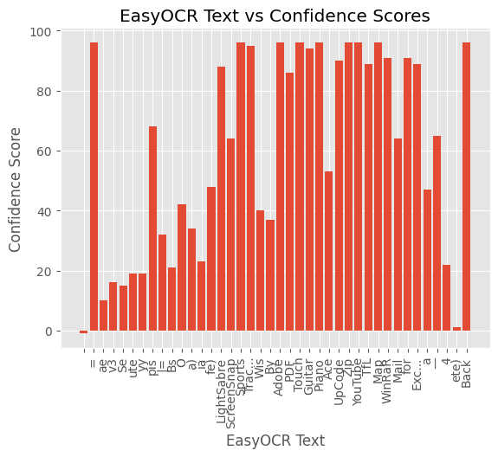Figure 8.4 EasyOCR Text vs Confidence Score

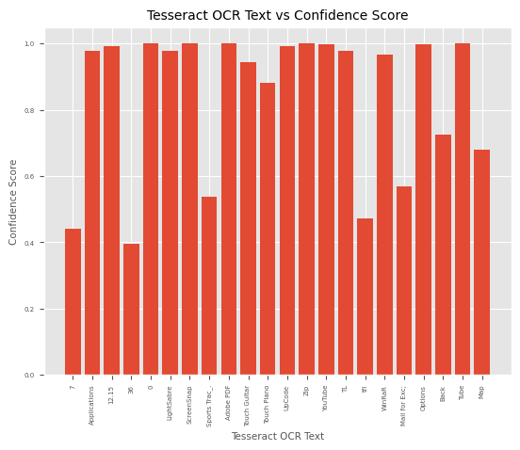

Figure 8.5 TesseractOCR Text vs Confidence Score

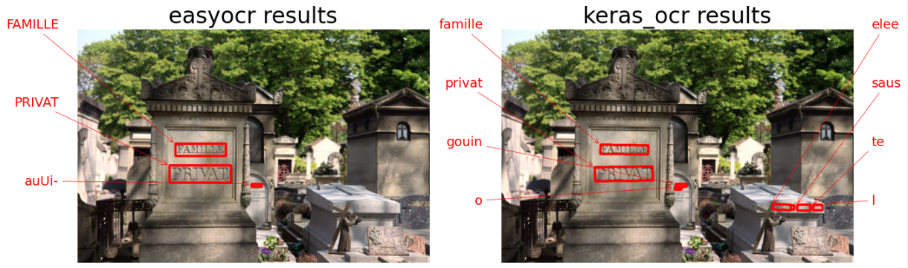

Figure 8.6 EasyOCR vs KerasOCR

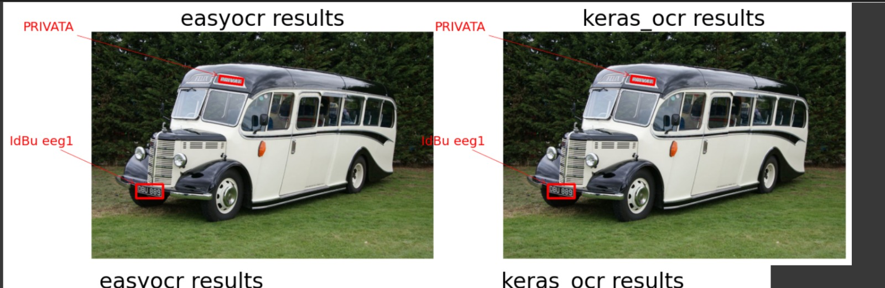

Figure 8.5 EasyOCR vs KerasOCR

The OCR results obtained using EasyOCR on the first two images of the dataset are as follows. In the first image, EasyOCR successfully detected the text "#" with a confidence score of 0.20, "B4*" with a confidence score of 0.14, "om.hk" with a high confidence score of 0.98, and "aebekae: 2926 7222 =" with a low confidence score of 0.06. Moving on to the second image, EasyOCR recognized the text "IdBu eeg1" with a confidence score of 0.13 and "PRIVATA" with a confidence score of 0.57.

The OCR results obtained using TesseractOCR on an image of the dataset is as follows. In the image, TesseractOCR successfully detected the text "NISSAN GENISS" with a confidence score of 0.793183, "NISSAN" with a high confidence score of 0.975665, "#1" with a small confidence score of 0.068619, "LHNa" with an insignificant confidence score of 0.038245, and "GENSS" with the highest confidence score of 0.993451.

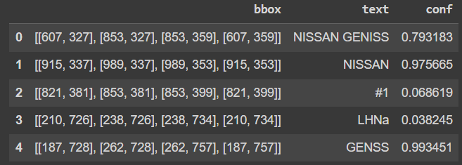

Figure 8.3 Tesseract OCR Result

Based on these findings, we made the decision to integrate the TeseractOCR module into our project. By doing so, we ensured that we could take full advantage of its superior performance considering both speed and accuracy. This choice allowed us to provide a reliable and efficient OCR solution within our project, meeting the requirements and expectations of our users.

By carefully evaluating and comparing the OCR capabilities of these algorithms and selecting the TesseractOCR algorithm as our preferred choice, we have taken a significant step toward enhancing the functionality and performance of our project. The integration of TeseractOCR ensures that our project can efficiently extract and process text from various image sources, further enriching the user experience and the overall effectiveness of our application.

# 

# 

# 

# 

# 

# 

# 

# 

# Chapter 9 Future Work

Eduline - Modern E-Learning Management System prioritizes a user-friendly and intuitive learning experience for students, instructors, and administrators. While the current version offers a comprehensive set of features and functionalities, there are opportunities for future development and enhancements. Potential areas for improvement include:

**Payment System:**

The current version of Eduline does not support online payments. Integrating a payment gateway would enable users to purchase courses directly through the platform.

**Social Media Integration:**

Adding social media integration would enable users to share course materials and information with their friends and followers, thus increasing the platform's visibility and reach.

**Personalized Learning:**

Customized learning paths based on individual preferences and past performance drive engagement and improve learning outcomes. Personalized approaches optimize understanding and retention by tailoring content to specific needs and incorporating preferred learning styles. This empowers students to take ownership of their education, resulting in increased engagement and improved learning success.

**Gamification:**

Integrating gamification elements like badges, leaderboards, and rewards makes learning fun and engaging, motivating students to complete courses and earn certifications.

# 

# Chapter 10 Conclusion

To sum up, Eduline - Modern E-Learning Management System offers a comprehensive and user-friendly platform that prioritizes a seamless learning experience for students, instructors, and administrators. With a variety of features and functionalities, such as student carts and wishlists, instructor OCR and analytics, and administrator authorization and unpublishing capabilities, Eduline aims to cater to the diverse needs of its users. The platform's responsive design ensures accessibility across different devices. While there is potential for future improvements, the current version of Eduline establishes a strong foundation for an efficient and reliable learning management system.

# References

1. E. H. -K. Wu, C. -H. Lin, Y. -Y. Ou, C. -Z. Liu, W. -K. Wang and C. -Y. Chao, "Advantages and Constraints of a Hybrid Model K-12 E-Learning Assistant Chatbot," in IEEE Access, vol. 8, pp. 77788-77801, 2020, doi: 10.1109/ACCESS.2020.2988252.
2. Al-Fraihat, Dimah, Joy, Mike, Masa'deh, Ra'ed and Sinclair, Jane (2020) Evaluating E-learning systems success : an empirical study. Computers in Human Behavior, 102 . pp. 67-86. doi:10.1016/j.chb.2019.08.004 ISSN 0747-5632
3. Snigdha Choudhury, Snigdha Pattnaik, Emerging themes in e-learning: A review from the stakeholders' perspective, Computers & Education, Volume 144, 2020, 103657, ISSN 0360-1315, https://doi.org/10.1016/j.compedu.2019.103657.
4. F. M. Enescu, G. Şerban and M. Jurian, "Web Platform for E-Learning," 2019 11th International Conference on Electronics, Computers and Artificial Intelligence (ECAI), Pitesti, Romania, 2019, pp. 1-6, doi: 10.1109/ECAI46879.2019.9042106.
5. B. Zhang, "Research on Educational Informatization Platform Based on E-learning Platform," 2021 IEEE Asia-Pacific Conference on Image Processing, Electronics and Computers (IPEC), Dalian, China, 2021, pp. 1043-1046, doi: 10.1109/IPEC51340.2021.9421207.
6. M. Bhatia and J. K. Maitra, "E-learning Platforms Security Issues and Vulnerability Analysis," 2018 International Conference on Computational and Characterization Techniques in Engineering & Sciences (CCTES), Lucknow, India, 2018, pp. 276-285, doi: 10.1109/CCTES.2018.8674115. give the literature review about this paper
7. Keskin, S. & Yurdugül, H. (2022). E-learning experience: Modeling students’ e-learning interactions using log data . Journal of Educational Technology and Online Learning , 5 (1) , 1-13 . DOI: 10.31681/jetol.938363
8. W. Bagunaid, N. Chilamkurti, and P. Veeraraghavan, “AISAR: Artificial Intelligence-Based Student Assessment and Recommendation System for E-Learning in Big Data,” Sustainability, vol. 14, no. 17, p. 10551, Aug. 2022, doi: 10.3390/su141710551.
9. B. Alojaiman, "Toward Selection of Trustworthy and Efficient E-Learning Platform," in IEEE Access, vol. 9, pp. 133889-133901, 2021, doi: 10.1109/ACCESS.2021.3114150.
10. E. H. F. Ezzahra, C. Mohamed and B. Abdelhamid, "Towards e-learning ecosystem model based on cloud computing," 2020 X International Conference on Virtual Campus (JICV), Tetouan, Morocco, 2020, pp. 1-4, doi: 10.1109/JICV51605.2020.9375724.
11. Rajasekaran, Vijay Anand, et al. "An Evaluation of E-Learning and User Satisfaction." IJWLTT vol.17, no.2 2022: pp.1-11. http://doi.org/10.4018/IJWLTT.20220301.oa3
12. J. Park, E. Lee, Y. Kim, I. Kang, H. I. Koo and N. I. Cho, "Multi-Lingual Optical Character Recognition System Using the Reinforcement Learning of Character Segmenter," in IEEE Access, vol. 8, pp. 174437-174448, 2020, doi: 10.1109/ACCESS.2020.3025769.
13. D. T. Bhabad, S. Therese and M. Gedam, "Multimedia based Information Retrieval Approach based on ASR and OCR and Video Recommendation System," 2017 International Conference on Current Trends in Computer, Electrical, Electronics and Communication (CTCIC), Mysore, India, 2017, pp. 1168-1172, doi: 10.1109/CTCEEC.2017.8455038.
14. K. Badwaik, K. Mahmood and A. Raza, "Towards applying OCR and Semantic Web to achieve optimal learning experience," 2017 IEEE 13th International Symposium on Autonomous Decentralized System (ISADS), Bangkok, Thailand, 2017, pp. 262-267, doi: 10.1109/ISADS.2017.40.
15. Kai-Yu Tang, Ching-Yi Chang & Gwo-Jen Hwang (2021) Trends in artificial intelligence-supported e-learning: a systematic review and co-citation network analysis (1998–2019), Interactive Learning Environments, DOI: [10.1080/10494820.2021.1875001](https://doi.org/10.1080/10494820.2021.1875001)
16. "Building an efficient OCR system for historical documents with little training data" by Jiří Martínek, Ladislav Lenc, and Pavel Král
17. Personalized E-Learning System Based on User’s Performance and Knowledge: An Adaptive Technique by Patchava. RamyaSree, Tammisetty. Bhuvaneswari, Vulchi. Vamsi Swapnika Reddy, Jonnalagadda. Surya Kiran
18. Optical character recognition with neural networks and post-correction with finite state methods by Senka Drobac1 · Krister Lindén
19. A. Kupiyalova, R. Satybaldiyev and S. Aiaskarov, "Semantic search using Natural Language Processing," 2020 IEEE 22nd Conference on Business Informatics (CBI), Antwerp, Belgium, 2020, pp. 96-100, doi: 10.1109/CBI49978.2020.10065.
20. J. Ariza, M. Jimeno, R. Villanueva-Polanco and J. Capacho, "Provisioning Computational Resources for Cloud-Based e-Learning Platforms Using Deep Learning Techniques," in IEEE Access, vol. 9, pp. 89798-89811, 2021, doi: 10.1109/ACCESS.2021.3090366.
21. R. Smith, "An Overview of the Tesseract OCR Engine," Ninth International Conference on Document Analysis and Recognition (ICDAR 2007), Curitiba, Brazil, 2007, pp. 629-633, doi: 10.1109/ICDAR.2007.4376991.
22. An OCR Post-processing Approach Based on Multi-knowledge by Li Zhuang & Xiaoyan Zhu
23. R. Farhat, Y. Mourali, M. Jemni and H. Ezzedine, "An overview of Machine Learning Technologies and their use in E-learning," 2020 International Multi-Conference on: “Organization of Knowledge and Advanced Technologies” (OCTA), Tunis, Tunisia, 2020, pp. 1-4, doi: 10.1109/OCTA49274.2020.9151758.
24. C. Fri and R. Elouahbi, "Machine Learning and Deep Learning applications in E-learning Systems: A Literature Survey using Topic Modeling Approach," 2020 6th IEEE Congress on Information Science and Technology (CiSt), Agadir -Essaouira,Morocco, 2020, pp. 267-273, doi: 10.1109/CiSt49399.2021.9357253.
25. A. Nikitha, J. Geetha and D. S. JayaLakshmi, "Handwritten Text Recognition using Deep Learning," 2020 International Conference on Recent Trends on Electronics, Information, Communication & Technology (RTEICT), Bangalore, India, 2020, pp. 388-392, doi: 10.1109/RTEICT49044.2020.9315679.

| **Sr. No.** | **PRN No.** | **Student Name** | **Individual Project Student Specific Objective** | **Learning Outcomes mapped ( To be filled by Guide )** | **Marks** |
| --- | --- | --- | --- | --- | --- |
| 1 | 1032190643 | Anjali Garje | Frontend UI design and Pages | * Client-side development * Create a user-friendly and intuitive user interface. * Utilize technologies like Angular, Angular Material, HTML, SCSS to achieve this goal. * Intense User Interface and design analysis. * To contribute to the development of a seamless and effective learning management system |  |
| 2 | 1032190670 | Kedar Patil | Database schema implementation and management | * To create a centralized and efficient system for storing, managing, and retrieving data relevant to the project. * Ensuring the relationship between the tables * Checking the connection of the database and the backend * Ensuring the consistency and integrity in the database |  |
| 3 | 1032190743 | Parth Gabhane | Backend service and API and implementing Semantic search | * Server-side development * Data management * API development * Performance optimization * Security and authentication * System architecture and design * Testing and debugging * Collaboration and communication * Contextual relevance * Natural language understanding * Query expansion and disambiguation * Enhanced search ranking and relevance’ * Connect all the modules of the project * Ensuring secure development by authorizing project details. * Guiding all members and solving any developer doubts * Making the module functional and efficient for professional use. |  |
| 4 | 1032190979 | Tejas Naphade | OCR implementation and testing of algorithms | * Understand OCR and its Applications * Various types of OCR Modules * Compared EasyOCR, KerasOCR and Tesseract OCR to check which model performs better and provides more accurate results. * Applied OCR on Course Material for Text Extraction from Images uploaded along with fuse. |  |

**Objectives and outcomes**

**Objectives:**

1. Provide a Comprehensive Learning Management System: The primary objective of the project is to develop a comprehensive learning management system that caters to the needs of students, instructors, and administrators. The platform should provide a seamless and intuitive experience for all users.
2. Implement Advanced Features: The project aims to implement advanced features such as semantic search, OCR for uploading course materials (Optical Character Recognition), course analytics, and user management. OCR will enable users to convert scanned or image-based documents into searchable and editable text, making it easier to incorporate external content into courses.
3. Enable Easy Course Creation and Material Upload: The project aims to provide instructors with an easy-to-use interface for creating and uploading courses. Instructors should be able to upload course materials in various formats, including PDFs, videos, images, and text.
4. Enhance Learning Experience for Students: The project aims to enhance the learning experience for students by providing a user-friendly dashboard, customizable features, and semantic search functionality. Students should be able to search for relevant courses and materials easily and navigate the platform efficiently.
5. Support Instructor Management and Interaction: The project aims to provide instructors with tools and features to manage their courses, monitor student progress, provide feedback and support, and customize course materials. The platform should facilitate effective interaction between instructors and students.
6. Provide Administrative Tools and Security: The project aims to provide administrators with tools and features to manage users, authorize courses and instructors, block users and instructors, and ensure the security and privacy of the platform. Strict login requirements and authentication procedures should be implemented.
7. Support Different Learning Styles and Accessibility: The project aims to support different learning styles by providing a range of multimedia formats, including videos, images, and text-based files. The platform should also be designed to be accessible, with features that enable users with disabilities to access and use the platform.
8. Ensure Scalability and Performance: The project aims to develop a scalable and high-performance platform that can handle a large number of users and courses. The platform should be optimized for speed and efficiency to provide a smooth user experience.
9. Future Expansion and Enhancement: The project aims to provide a foundation for future expansion and enhancement of the platform. It should be designed in a modular and flexible manner to accommodate future feature additions and improvements.

**Outcomes-**

1. Seamless: The platform provides a seamless learning experience for users.
2. User-friendly: Eduline offers a user-friendly interface that is easy to navigate.
3. Comprehensive: The platform caters to the needs of students, instructors, and administrators.
4. Intuitive: The platform provides an intuitive user experience.
5. Efficient: Eduline offers efficient tools and features for online education.
6. Modern: Eduline has a modern design and incorporates cutting-edge technologies.
7. Responsive: The platform is optimized for various devices and screen sizes

**Plagiarism Report**

